**ONLINE RATING WEBSITE**

**TEAM MEMBERS**

**OSHO AGYEYA-15BCE1326**

**SHUBHAM PARASHAR-15BCE1318**

**SHRIANSH SRIVASTAVA-15BCE1314**

**KASHISH MIGLANI-15BCE1003**

**ANIMESH SENGUPTA-15BCE1198**

**FINAL REVIEW DOCUMENT**



**SUBMITTED TO-:**

**GRACELINE MA’AM**

**CSE DEPARTMENT**

**VIT UNIVERSITY, CHENNAI CAMPUS**

**ACKNOWLEDGEMENT**

**We would like to express our special thanks of gratitude to our teacher Graceline Jasmine Ma’am as well as our program chair Dr R Ganesan sir who gave us the golden opportunity to do this wonderful project on the topic Hostel Management System for college events which also helped us in doing a lot of Research and we came to know about so many new things. We are really thankful to them. Secondly we would also like to thank our parents and friends who helped us a lot in finalizing this project within the limited time frame.**

**ABSTRACT**

The online hostel management system works on the backbone of database and tables. The website has been developed to do away with old and obsolete system of website and bring a new website with new, better and up-to date functionalities such as search by clause, leave form acceptance, online order receiving, dashboard for messages etc.

The website uses the back end and database to fetch results.

**ER – MODEL**

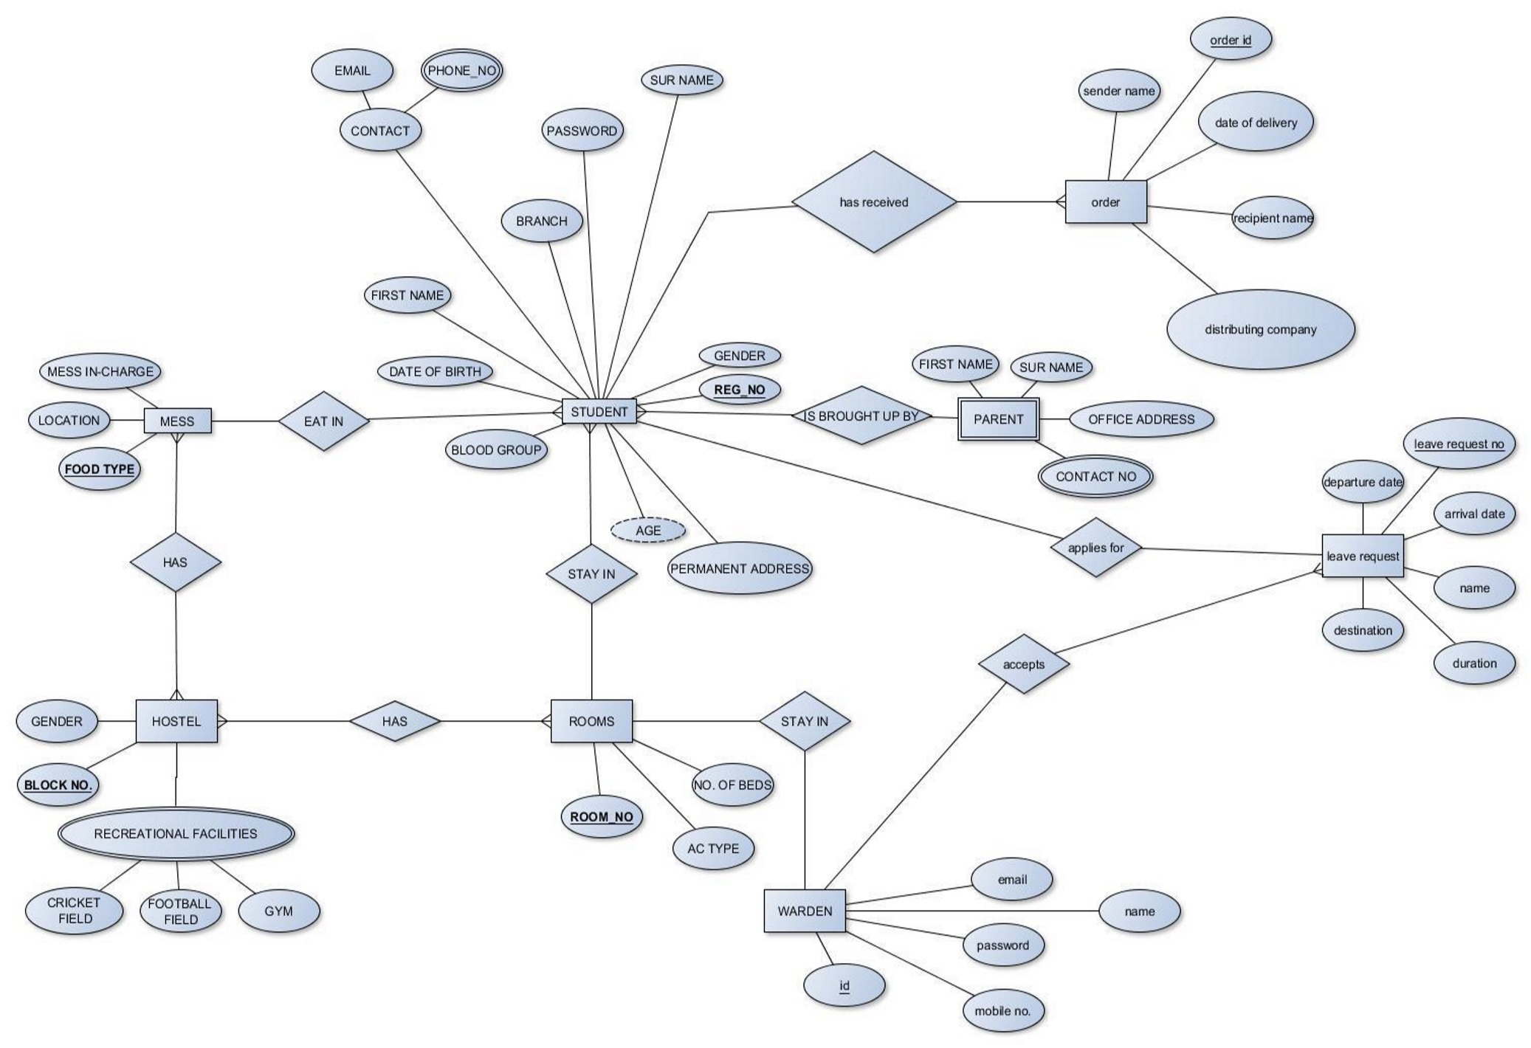

The ER-model has been included for the understanding of the tables and their dependencies. The relations have been clearly mentioned and the dependencies and relations are given.

The student as an entity does the following-:

Eats in MESS

Stays in ROOM

Receives ORDER

Applies for LEAVE REQUEST

Similarly, all the functionalities of each entity have been mentioned in the E-R diagram.

The various attributes of the entities has also been mentioned clearly to understand each table and their column in the actual database.

The other entities that are included are-:

* Mess
* Room • Order
* Hostel

For each of the given entity the attributes and relations have been mentioned.

**MODULES/FUNCTIONALITIES**

**Module-1**

The first module of our website comprises of Welcome page user sign-up and login. The user sign-up and login have been validated using JavaScript. The sign-up enables a user to be a member of the website and from then onwards the user can login and access the various functionalities of the website.

The sign-up and login form have been styled using CSS.

**Welcome Page and Login**

The home page has been styled using CSS and allows the user to login and register for the website.

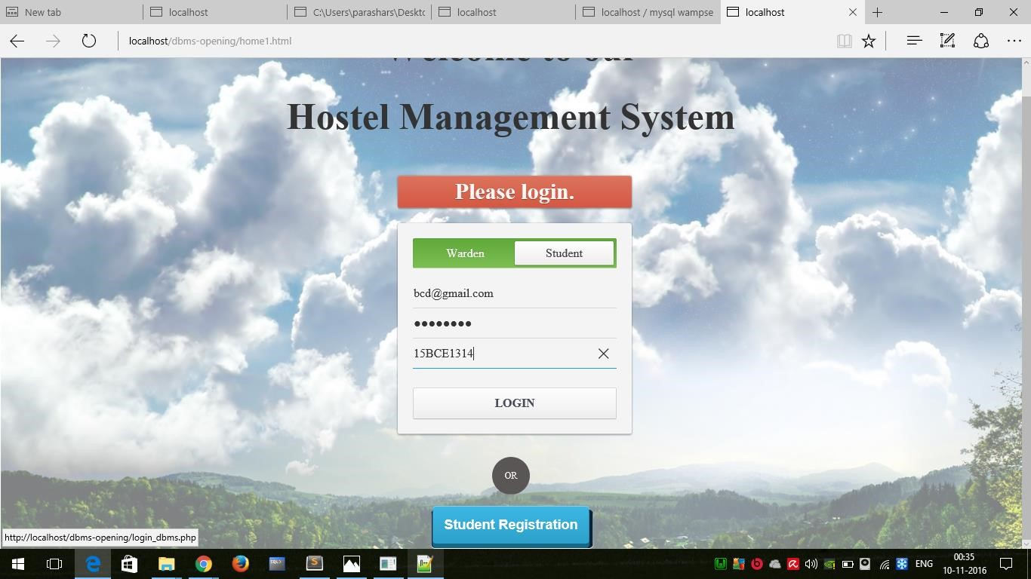

**Sign Up Page**

The sign-up page has been dynamically designed using HTML and CSS and has user validation with it. The sign-up is available for user as well as admin.

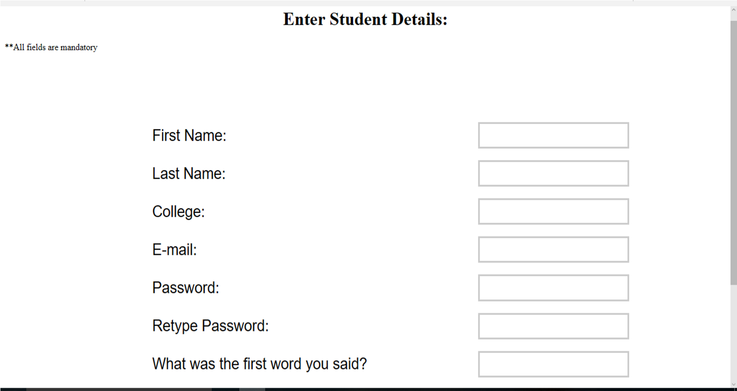

**Module-2**

The module comprises of the inner part of the website which is the home page, admin homepage, the overall functionality, the menu bar and user profile.

The user gets to interact with the website through this module and can view the functionalities of the website. It allows the user to view events by college or date and also lets the user rate them and know about them.

The users can also view their profile.

**Home page**

The home page comprises of a dynamically designed filter and a dashboard featuring all the major events of the hostel that have been covered in the website. The filter can change the dashboard according to the college selected. The user can also click on the event button to view the desired thing.

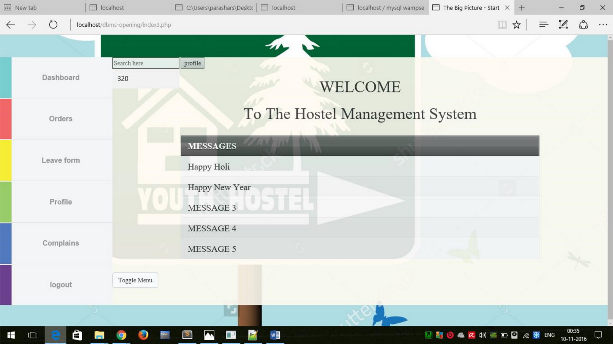

**User Profile**

* Users can view their profile by clicking on the view profile button and in his profile they can view the following things-

* 1. First Name
  2. Last Name
  3. Room number
  4. Mess type
  5. Room Type

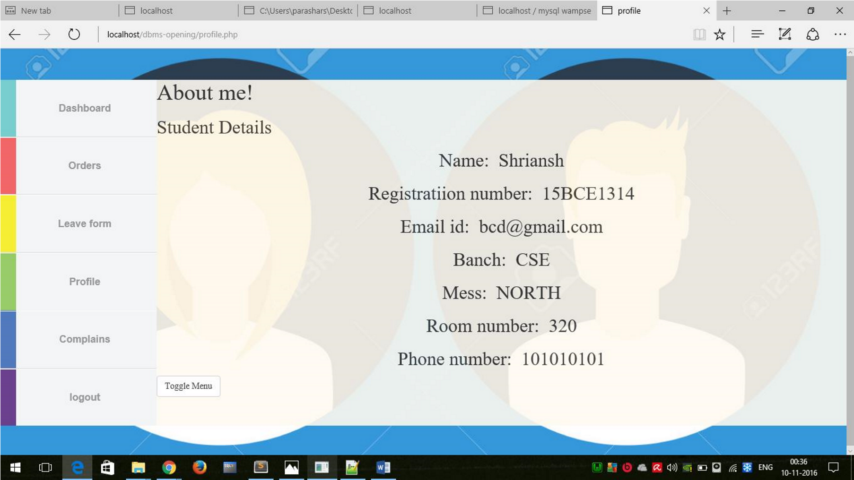

**Admin Homepage**

This page comprises of all the admin functionality that is

* He/she can search accept leave forms, search students by query, see complaints, online orders acceptance.

At last there is the logout button.

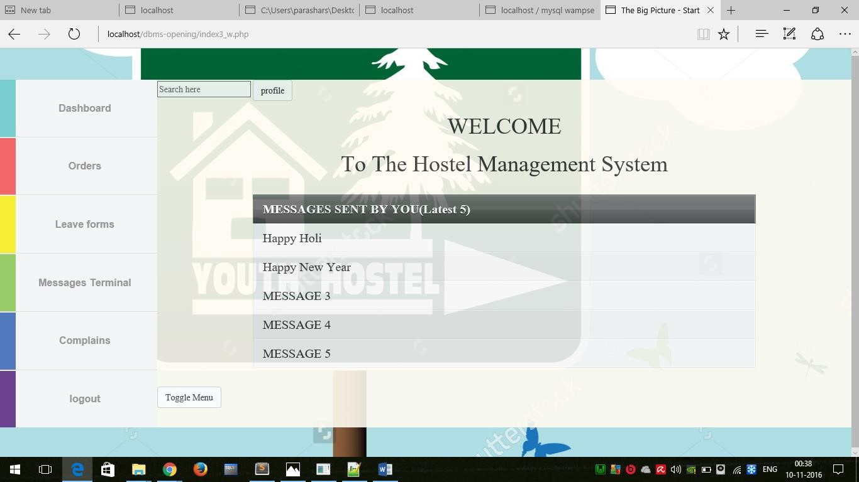

**MODULE-3**

The third module comprises of the inner important functionalities of the website such as searching a student by query, dashboard updating, hostel complaints, viewing status of online orders, applying for leave forms etc.

It also includes the overall working of the website and the basic functionality of the website.

**Dashboard/Messages**

The basic portal for the user to see and view all the functionalities of the website, and to also see the messages the student may have got. The dashboard is basically the backbone of the home page.

The messages are also fetched from the database and are presented to the user.

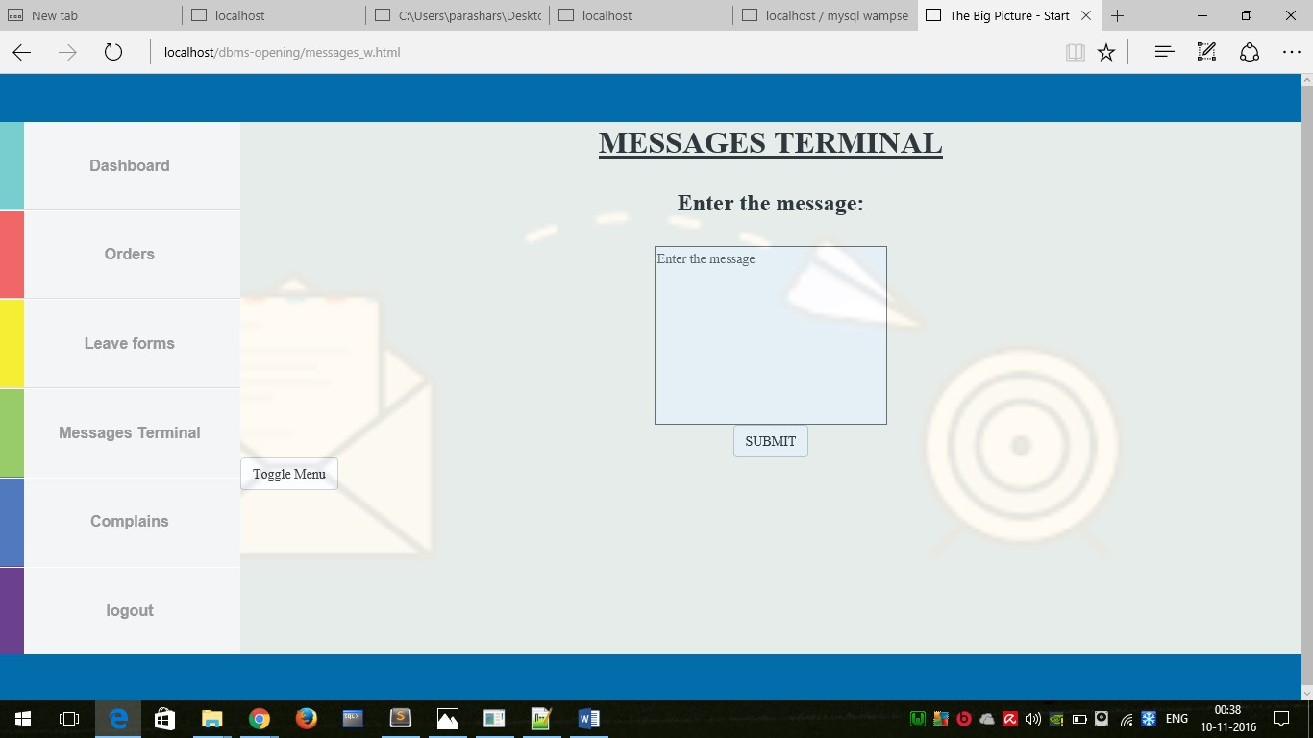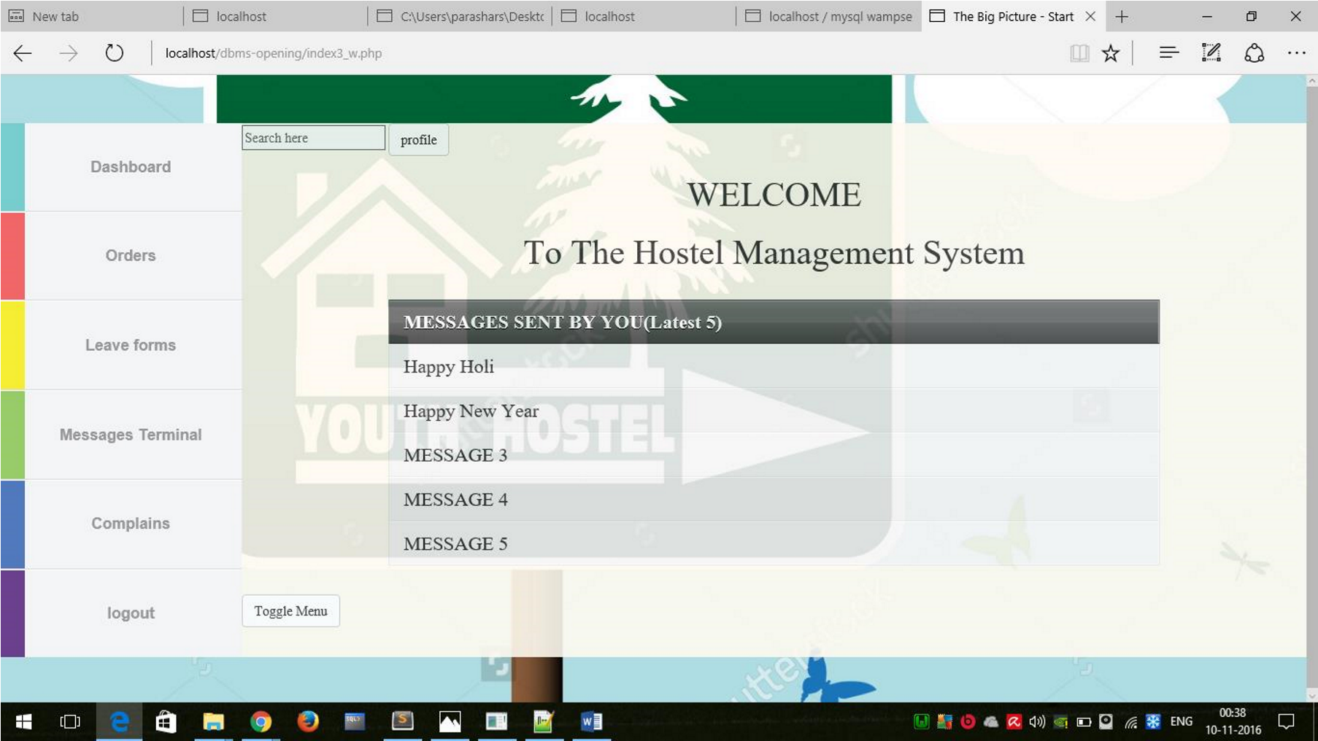

**Search by Query**

It is based purely on database where a person can search hostel members by clause such as registration number, name, mess type etc. It uses database fetching on condition functionality.

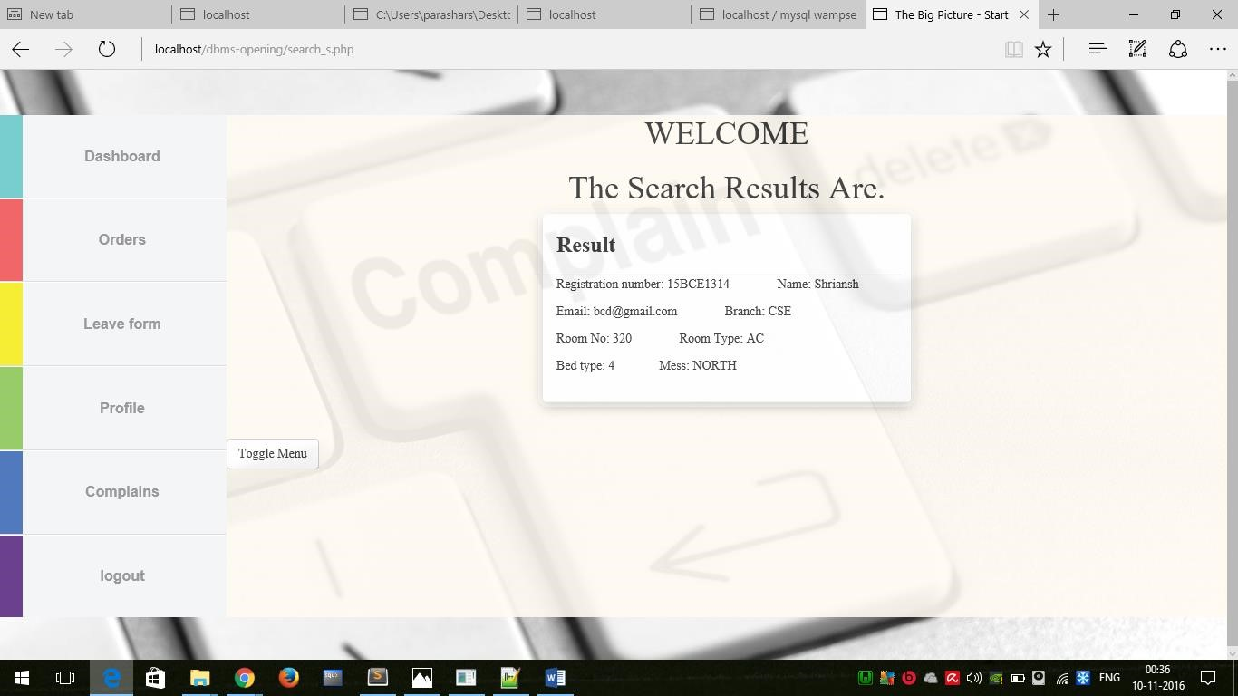

**Leave forms**

The leave form has been included so that the student can apply for it online and the warden can get the applied form and accept or reject it.

It works on the table functionality only, where the student’s applied response in stored in a table and the same table result in fetched to the warden home page so that he/she can accept or reject the form.

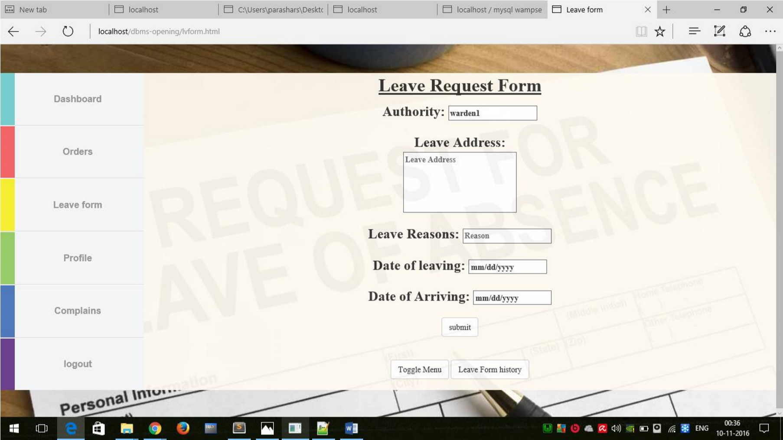

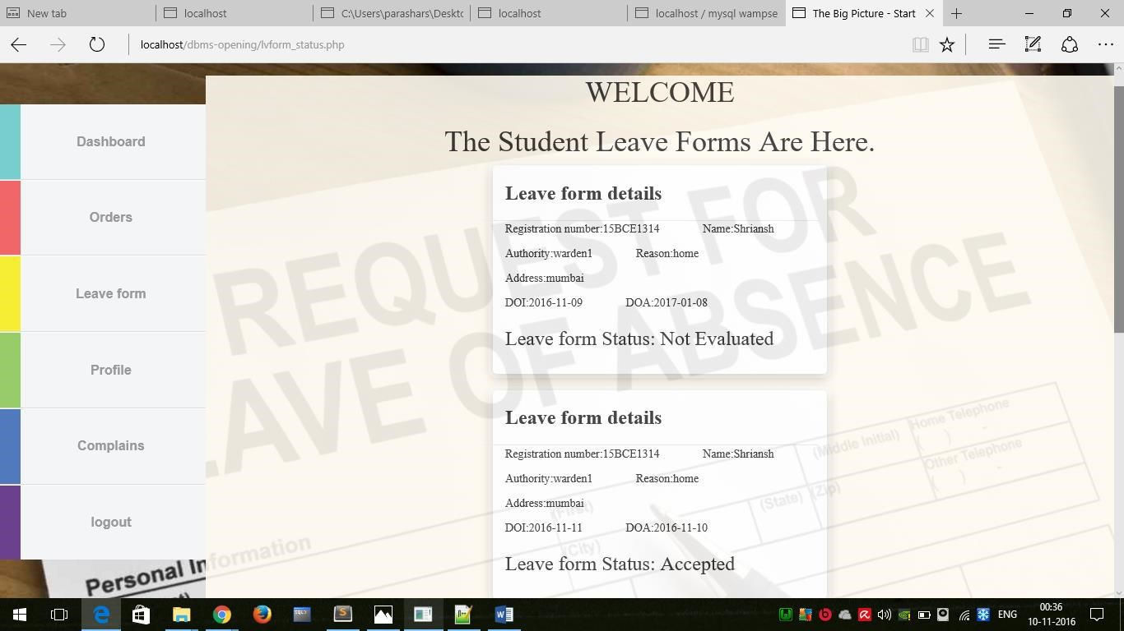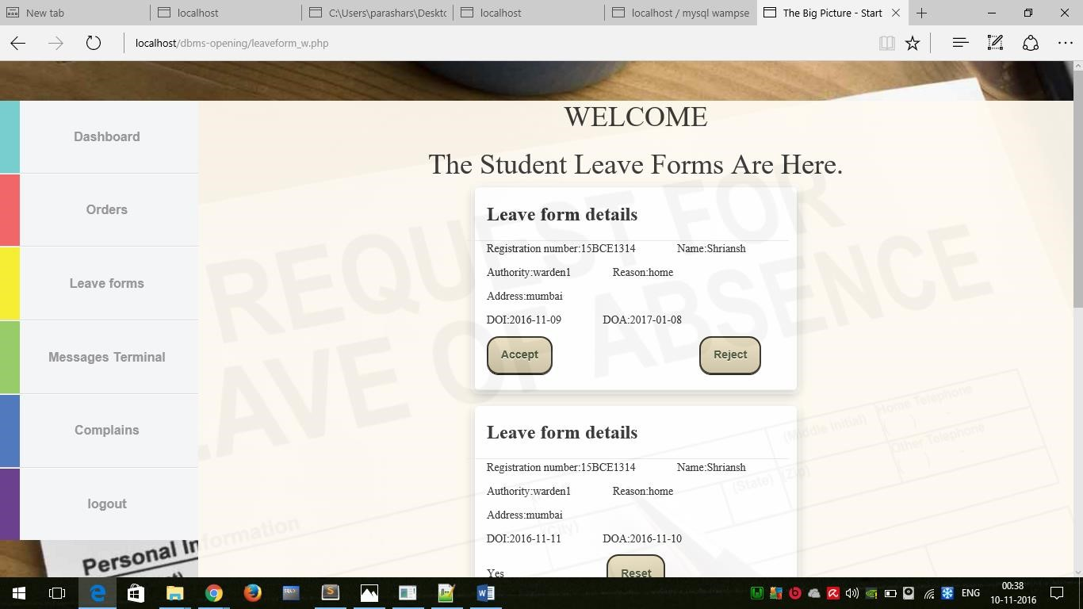

**Hostel Complaints**

The hostel complaints have been added so that students can give their complaints of the hostel of various kinds to the warden and the warden can take required action by accepting or rejecting the complaint.

The complaint table is again brought into picture and the result is fetched to the warden home page.

It eases the complaint procedure of the students.

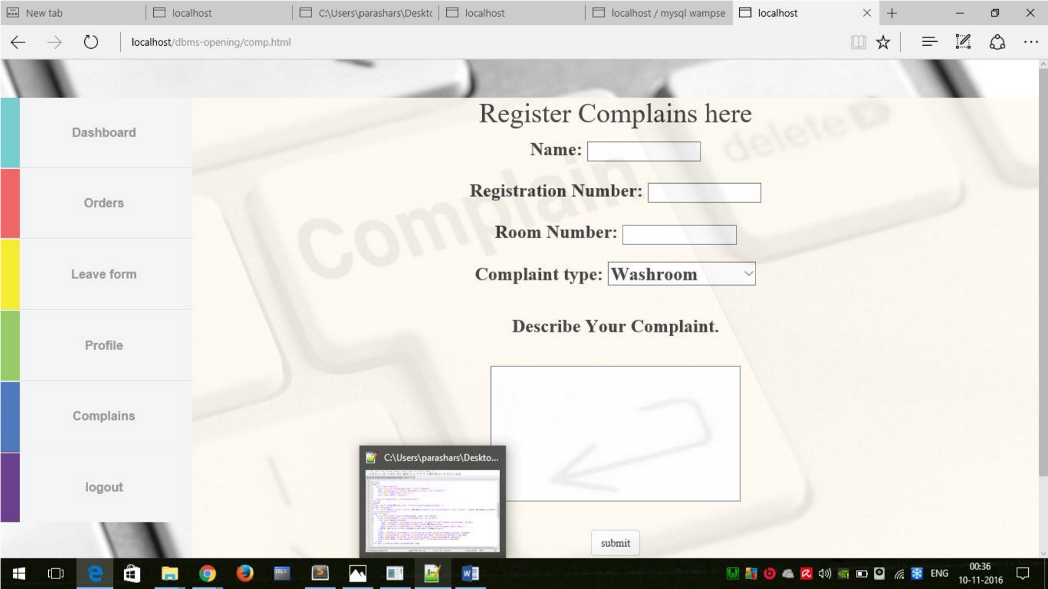

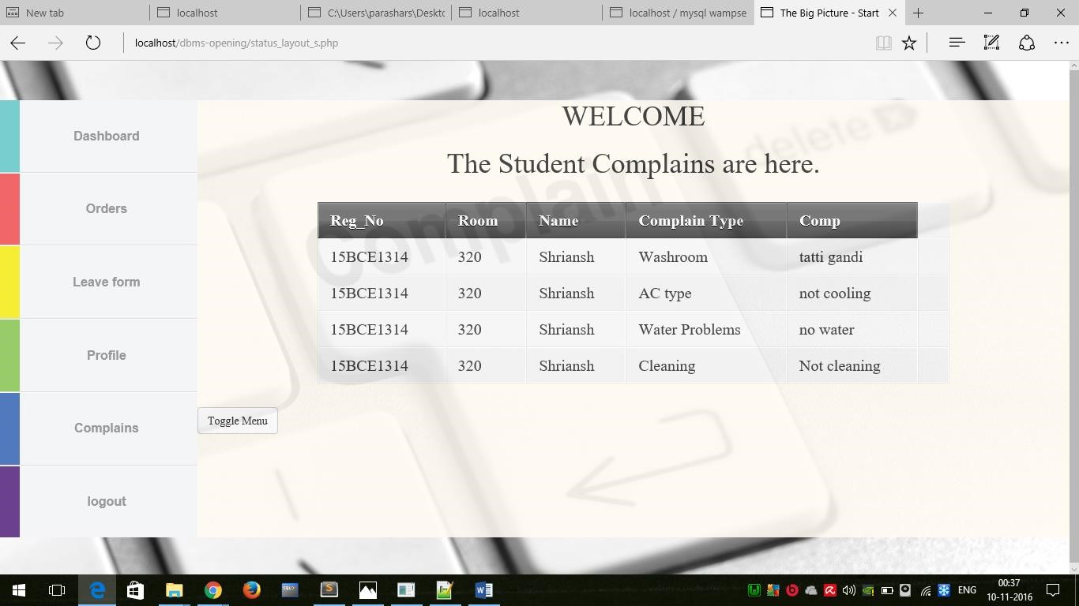

**Online Orders**

The online order functionality has been added so that the student could know the status about his online orders on the website itself instead of physically going and checking again and again.

The online order

table is updated each time the user

has an order for him/her.

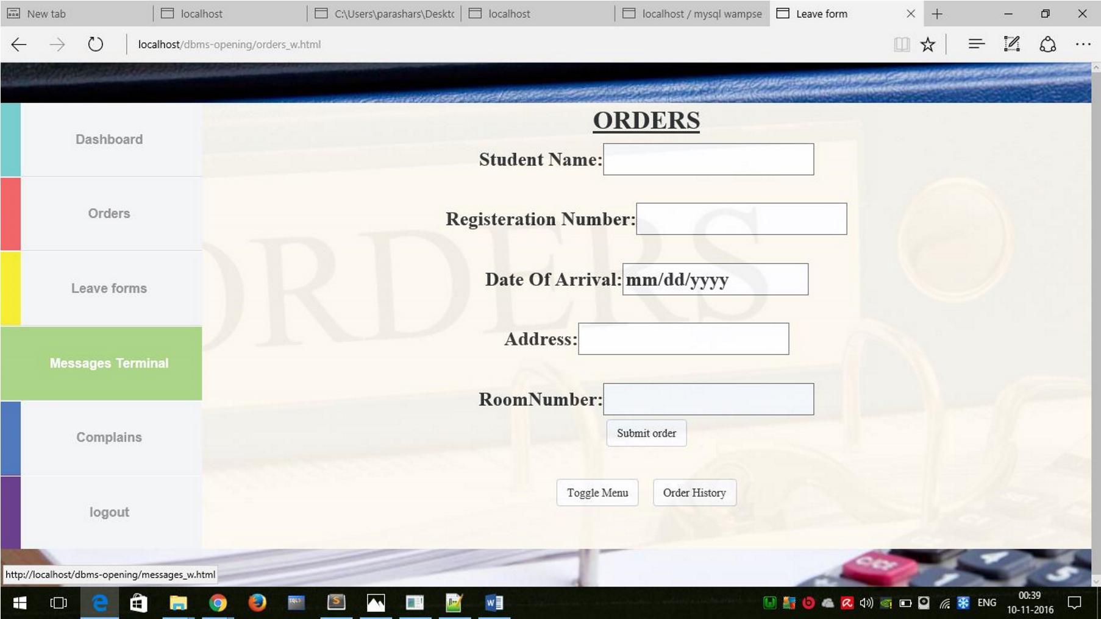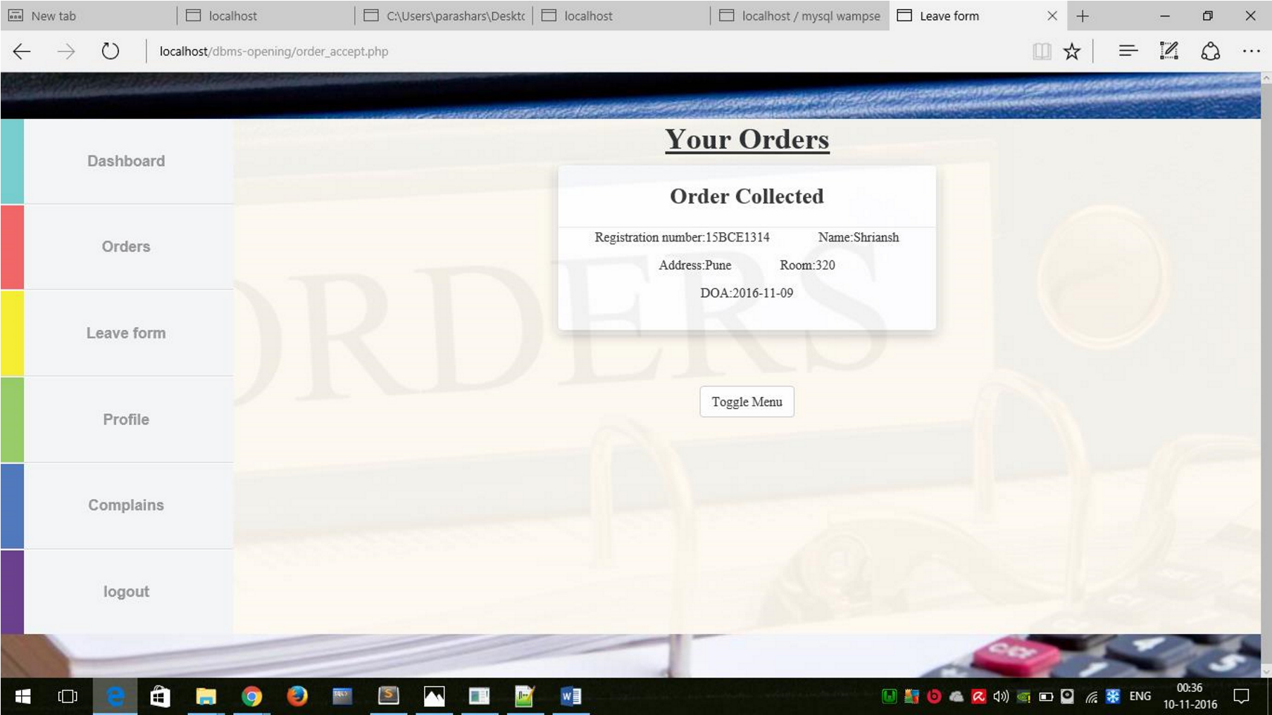

**Logout**

Finally, the logout button is there to get out of the website and active session.

**SCHEMA/STUCTURE OF TABLES USED**

The structure of table is mentioned along with columns etc. to understand the database schema completely.

Each table has different columns which are mentioned clearly.

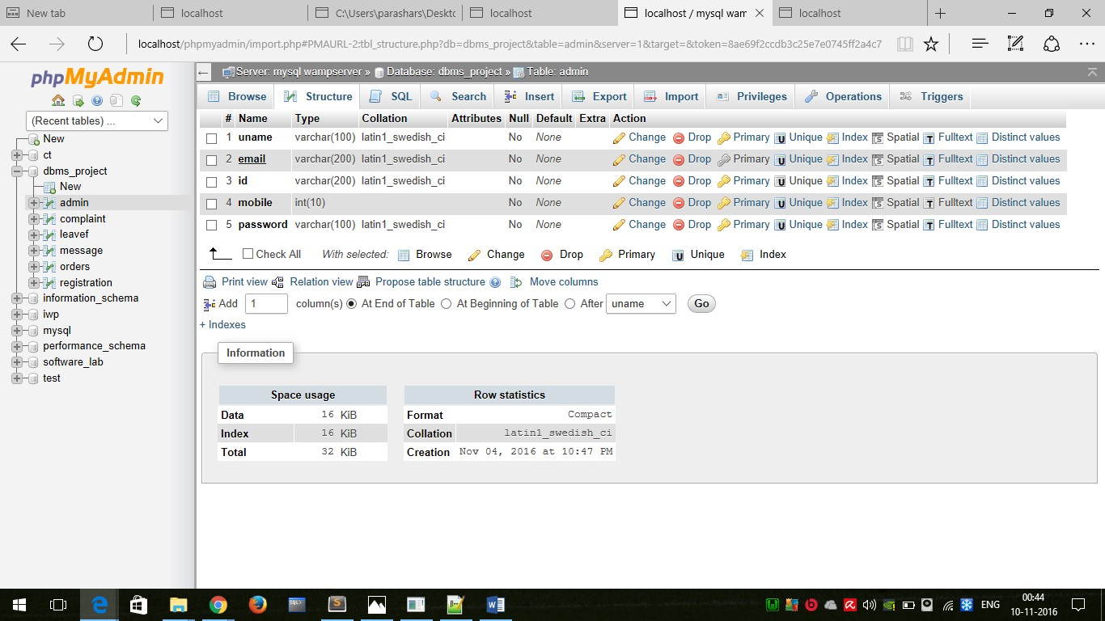

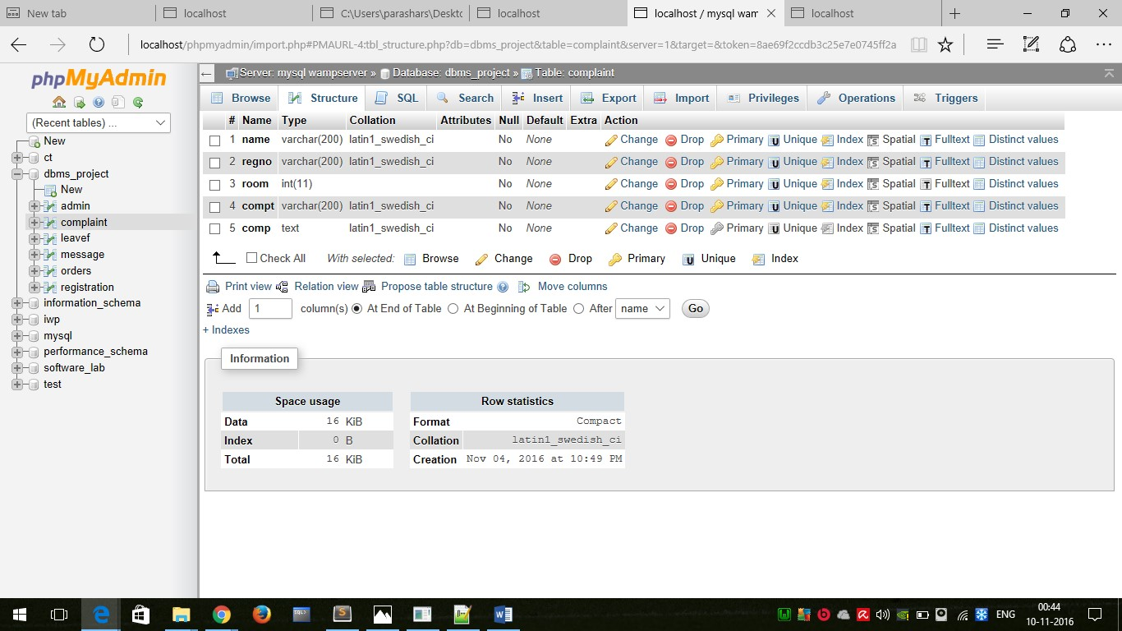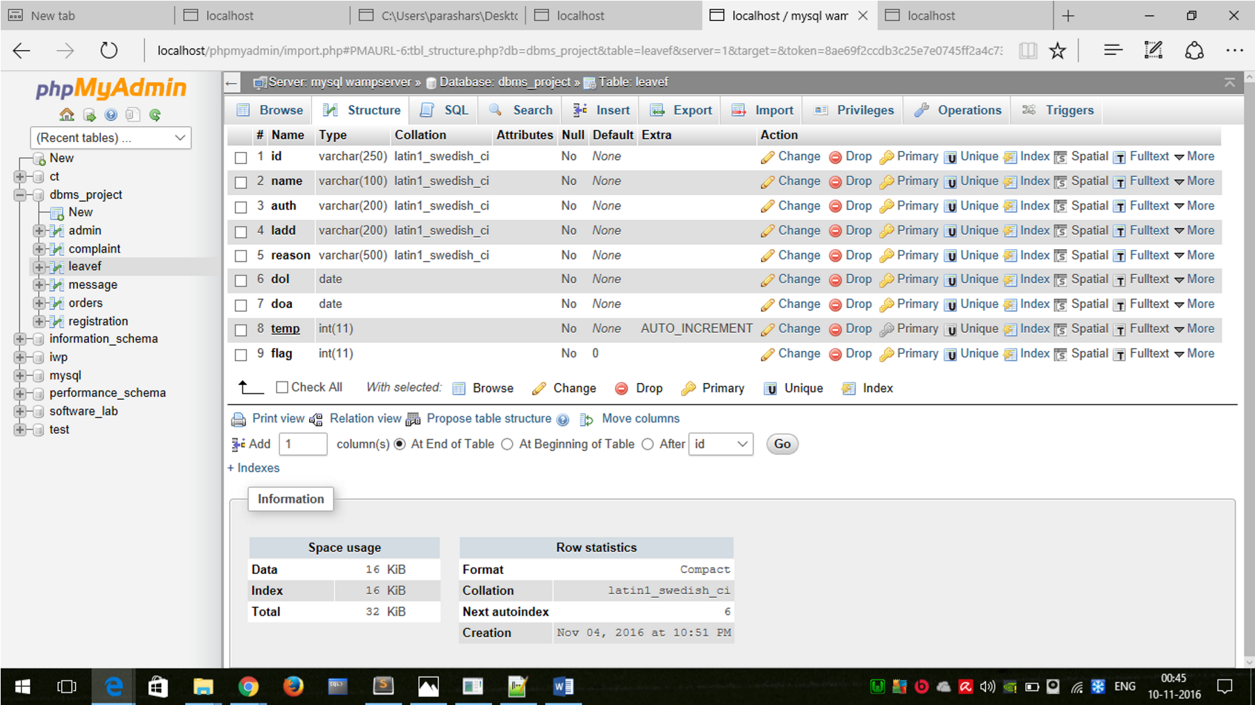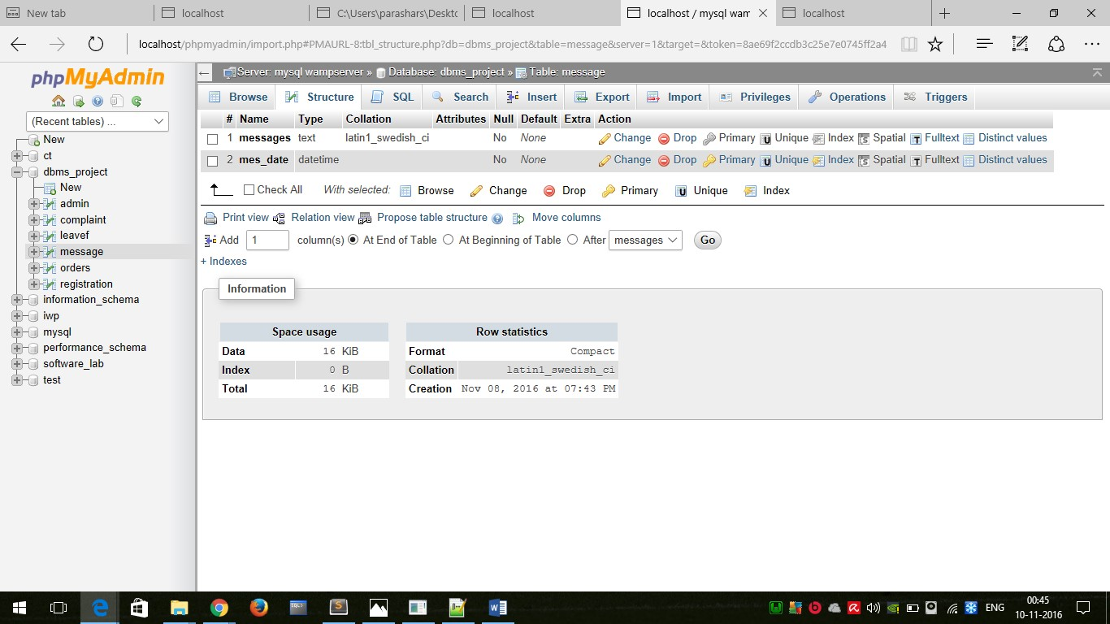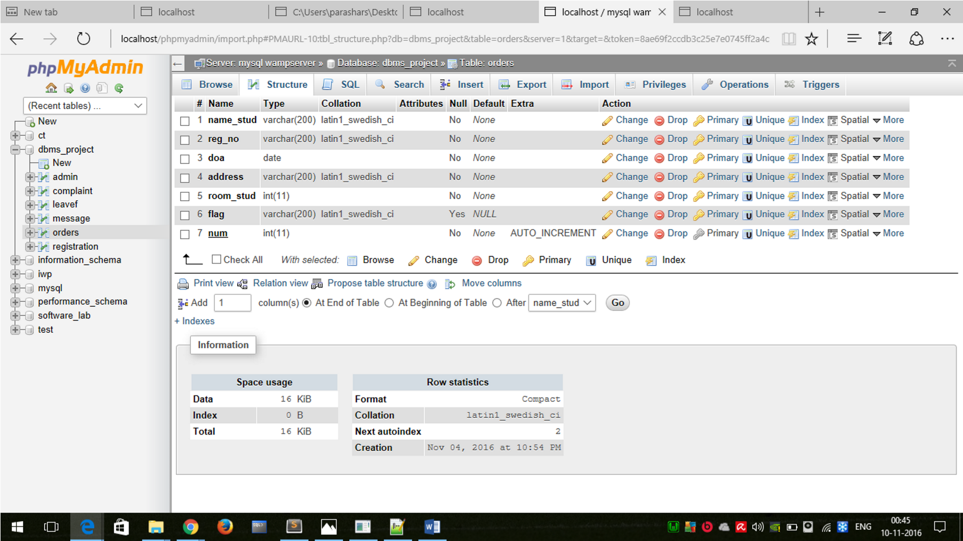

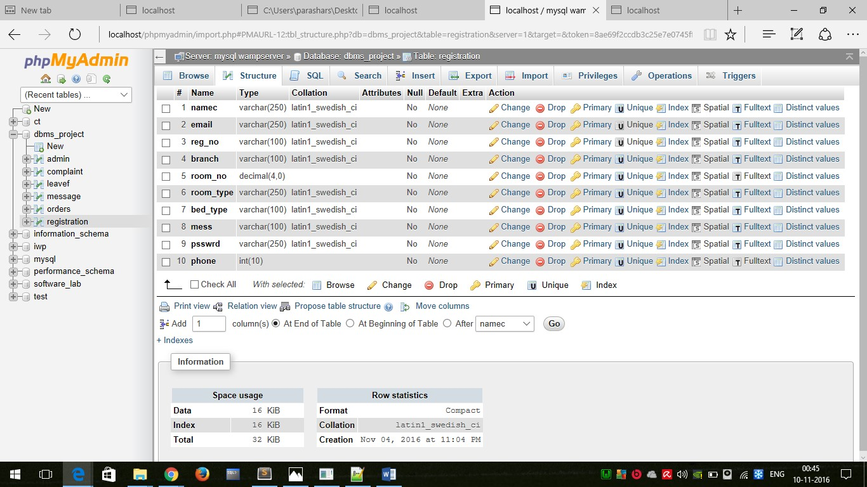

**Normalisation of Tables**



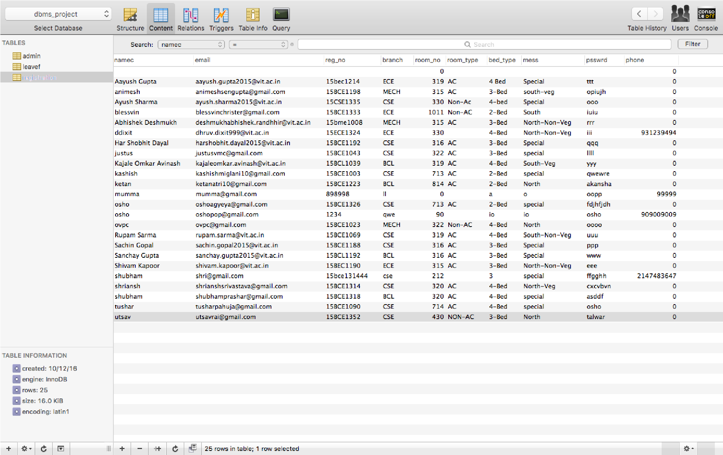

**Given functional dependencies for table registration:**

**reg_no->namec, email, branch, psswrd, phone, room_no,mess room_no->room_type,bed_type**

**1NF:**

For this table:

1. values of each attribute are atomic
2. no composite values
3. all entries are of same kind
4. each column has unique name
5. no 2 rows are identical

Therefore it is in 1st normal form.

**2NF:**

A relation is in 2NF if it is in 1NF and all non-prime attributes are fully functionally dependant on each candidate key of R. Here, candidate key is reg_no. Therefore non-prime attributes are namec, email, branch, psswrd, phone, room_no, mess ,room_type, bed_type. All of them are fully functionally dependent on the candidate key. Therefore, the table is in 2NF.

**3NF:**

A relation is in 3NF if it is in 2NF and no non prime attribute is transitively dependant on candidate key or in other words, there should not be the case that a non-prime attribute is determined by another non-prime attribute. Here, non prime attributes are namec, email, branch, psswrd, phone, room_no, mess ,room_type, bed_type, but room_type,bed_type are determined by room_no . Therefore the table is not in 3NF. Now, to convert it into 3NF, we break the table registration as follows:

registration= registration1(reg_no,namec,email,branch,psswrd,phone,room_no,mess)

Its functional dependencies are:

reg_no->namec, email, branch, psswrd, phone, room_no,mess

+ registration2(room_no,room_type,bed_type)

Its functional dependencies are: room_no->room_type,bed_type

Now the table is in 3NF.

**BCNF:**

A relation is in BCNF if it is in 3NF and for each X->Y , X is a super key. For table

registration1(reg_no,namec,email,branch,psswrd,phone,room_no,mess) Its functional dependencies are:

reg_no->namec, email, branch, psswrd, phone, room_no,mess Here reg_no is a super key. Therefore this table is in BCNF. For table registration2(room_no,room_type,bed_type) Its functional dependencies are: room_no->room_type,bed_type

Here room_no is the superkey. Therefore this table is also in BCNF.

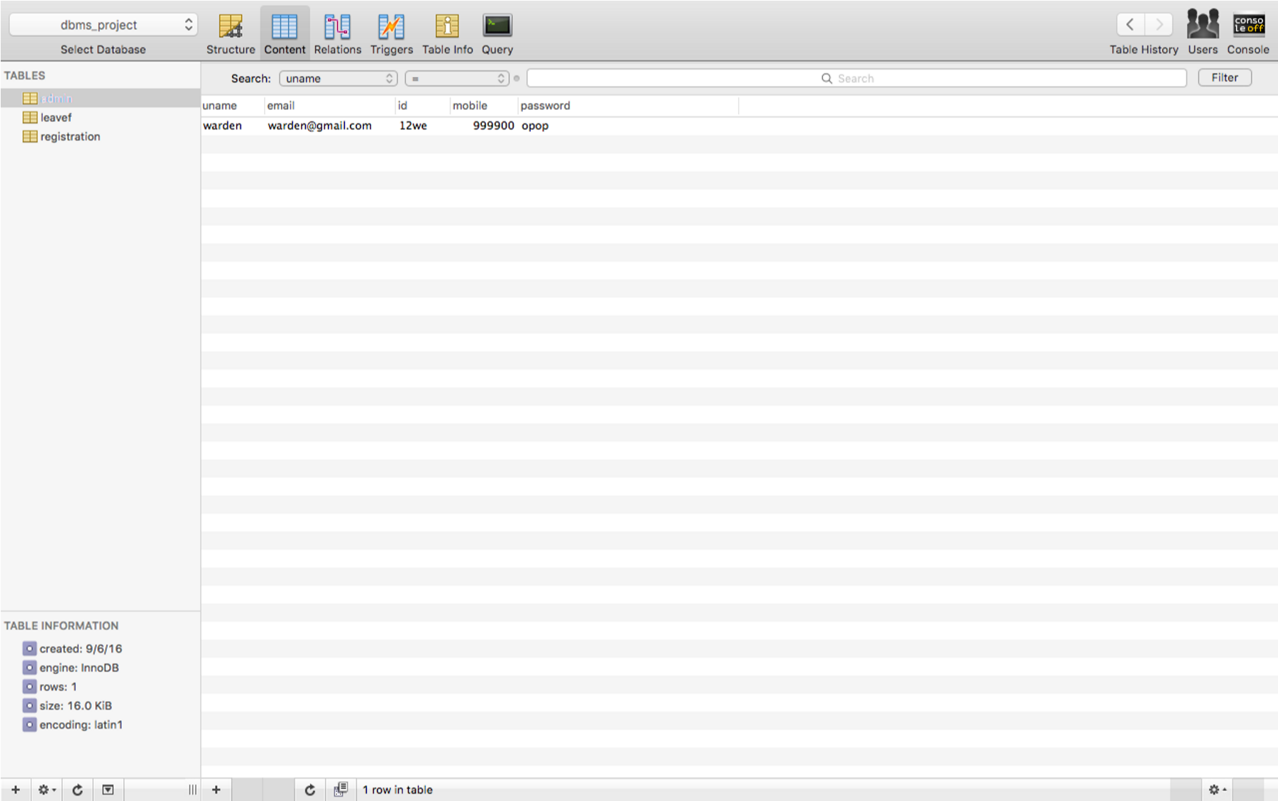

**Given functional dependencies for table admin:**

**id->uname,email,mobile,password**

**1NF:**

For this table:

1. values of each attribute are atomic
2. no composite values
3. all entries are of same kind
4. each column has unique name
5. no 2 rows are identical

Therefore in 1st normal form.

**2NF:**

A relation is in 2NF if it is in 1NF and all non-prime attributes are fully functionally dependant on each candidate key of R. Here, candidate key is id. Therefore non-prime attributes are uname, email,mobile,password. All of them are fully functionally dependent on the candidate key. Therefore, the table is in 2NF.

**3NF:**

A relation is in 3NF if it is in 2NF and no non prime attribute is transitively dependant on candidate key or in other words, there should not be the case that a non-prime attribute is determined by another non-prime attribute. Here, non prime attributes are uname,email,mobile,password and all are determined by the candidate key only. Therefore the table is in 3NF.

**BCNF:**

A relation is in BCNF if it is in 3NF and for each X->Y , X is a super key. Here for table admin, id is a super key. Therefore the table is in BCNF.

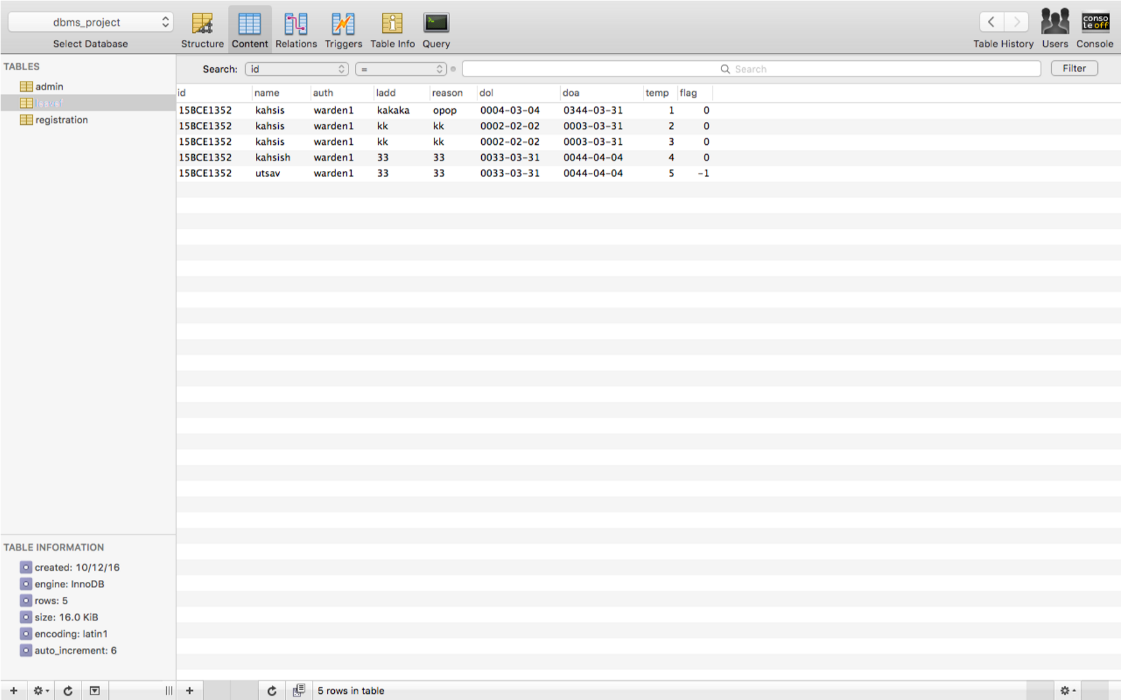

**Given functional dependencies for table leavef: id,temp->name,reason,ladd,auth reason->dol,doa**

**1NF:**

For this table:

1. values of each attribute are atomic
2. no composite values
3. all entries are of same kind
4. each column has unique name
5. no 2 rows are identical

Therefore in 1st normal form.

**2NF:**

A relation is in 2NF if it is in 1NF and all non-prime attributes are fully functionally dependant on each candidate key of R. Here, candidate key is

(id,temp). Therefore non-prime attributes are name, reason,ladd,auth,reason,dol,doa. All of them are fully functionally dependent on the candidate key. Therefore, the table is in 2NF.

**3NF:**

A relation is in 3NF if it is in 2NF and no non prime attribute is transitively dependant on candidate key or in other words, there should not be the case that a non-prime attribute is determined by another non-prime attribute. Here, non prime attributes are name, reason,ladd,auth,reason,dol,doa but dol,doa is determined by reason. Therefore the table is not in 3NF. Now, to convert it into 3NF, we break the table leavef as follows:

leavef=leavef1(id,temp,name,reason,ladd,auth)

Its functional dependencies are:

id,temp->name,reason,ladd,auth

+ leavef2(reason,dol,doa) Its functional dependencies are: reason->dol,doa

Now the table is in 3NF.

**BCNF:**

A relation is in BCNF if it is in 3NF and for each X->Y , X is a super key. Here for table leavef=leavef1(id,temp,name,reason,ladd,auth)

Its functional dependencies are:

id,temp->name,reason,ladd,auth

(id,temp) is a super key. Therefore, the table is in BCNF. For table leavef2(reason,dol,doa) Its functional dependencies are:

reason->dol,doa

Here , reason is a super key. Therefore, the table is in BCNF.

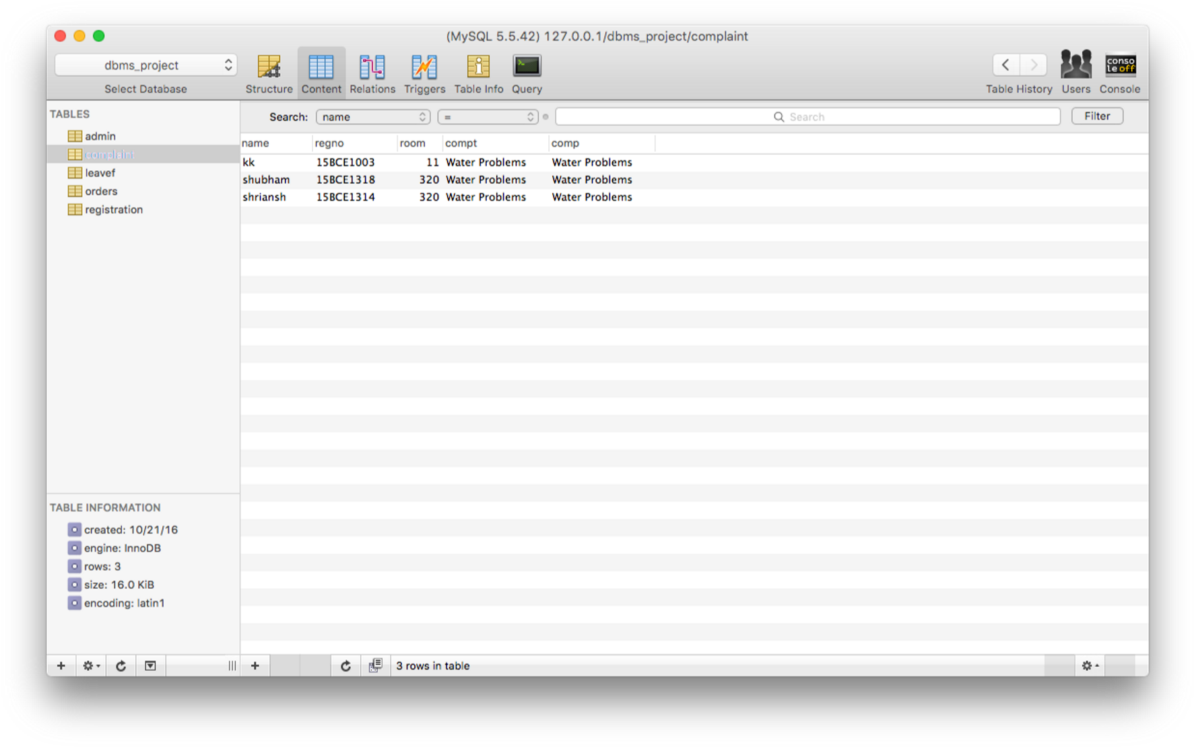

**Given functional dependencies for table complaint( assuming one student from a room can lodge only one complaint)** **reg_no->name,room name->compt compt->comp**

**1NF:**

For this table:

1. values of each attribute are atomic
2. no composite values
3. all entries are of same kind
4. each column has unique name
5. no 2 rows are identical Therefore in 1st normal form. **2NF:**

A relation is in 2NF if it is in 1NF and all non-prime attributes are fully functionally dependant on each candidate key of R. Here, candidate key is (reg_no). Therefore non-prime attributes are name, room,compt,comp. All of them are fully functionally dependent on the candidate key. Therefore, the table is in 2NF.

**3NF:**

A relation is in 3NF if it is in 2NF and no non prime attribute is transitively dependant on candidate key or in other words, there should not be the case that a non-prime attribute is determined by another non-prime attribute. Here, non prime attributes are name, room,compt,comp but compt is determined by name and comp is determined by compt. Therefore the table is not in 3NF. Now, to convert it into 3NF, we break the table leavef as follows:

complaint=complaint1(reg_no,name,room)

Its functional dependencies are:

reg_no->name,room

+

complaint2(name,compt)

Its functional dependencies are:

name->compt

+

complaint3(compt.comp)

Its functional dependencies are:

compt->comp

Now the table is in 3NF.

**BCNF:**

A relation is in BCNF if it is in 3NF and for each X->Y , X is a super key. Here for table complaint1(reg_no,name,room) Its functional dependencies are:

reg_no->name,room reg_no is a super key. Therefore, this table is in BCNF. For table

complaint2(name,compt)

Its functional dependencies are:

name->compt name is super key. . Therefore, this table is in BCNF. For table

complaint3(compt,comp)

Its functional dependencies are:

compt->comp

Here, compt is a super key. Therefore, the table is in BCNF.

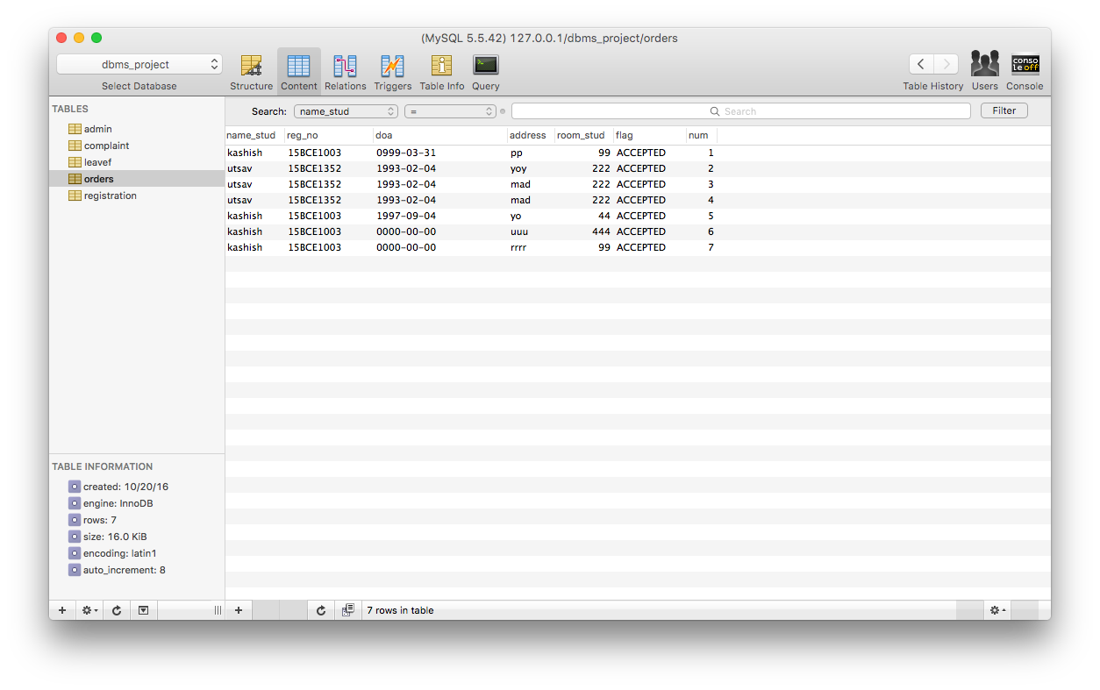

**Given functional dependencies for table orders** **num->name_stud,reg_no,doa,address,room_stud reg_no->name_stud,room_stud address->doa**

**1NF:**

For this table:

1. values of each attribute are atomic
2. no composite values
3. all entries are of same kind
4. each column has unique name
5. no 2 rows are identical

Therefore in 1st normal form.

**2NF:**

A relation is in 2NF if it is in 1NF and all non-prime attributes are fully functionally dependant on each candidate key of R. Here, candidate key is

(num). Therefore non-prime attributes are name_stud, reg_no,doa,address,room_stud. All of them are fully functionally dependent on the candidate key. Therefore, the table is in 2NF.

**3NF:**

A relation is in 3NF if it is in 2NF and no non prime attribute is transitively dependant on candidate key or in other words, there should not be the case that a non-prime attribute is determined by another non-prime attribute. Here, non prime attributes are name_stud, reg_no,doa,address,room_stud.But name_stud,room_stud are determined by reg_no. Also, doa is determined by address. Therefore the table is not in 3NF. Now, to convert it into 3NF, we break the table orders as follows: orders=orders1(num,reg_no,address)

Its functional dependencies are:

**num->,reg_no,address**

+

order2(reg_no,name_stud,room_stud)

Its functional dependencies are: **reg_no->name_stud,room_stud**

+ orders3(address,doa)

Its functional dependencies are:

**address->doa**

Now the table is in 3NF.

**BCNF:**

A relation is in BCNF if it is in 3NF and for each X->Y , X is a super key. Here for table orders=orders1(num,reg_no,address)

Its functional dependencies are:

num->,reg_no,address here,num is super key. Therefore the table is in BCNF. For table order2(reg_no,name_stud,room_stud)

Its functional dependencies are: reg_no->name_stud,room_stud

reg_no is super key. Therefore the table is in BCNF.

For table orders3(address,doa)

Its functional dependencies are:

address->doa

Here, address is super key. Therefore the table is in BCNF.

**ALL NORMALISED TABLES AND THEIR SCREENSHOTS:**

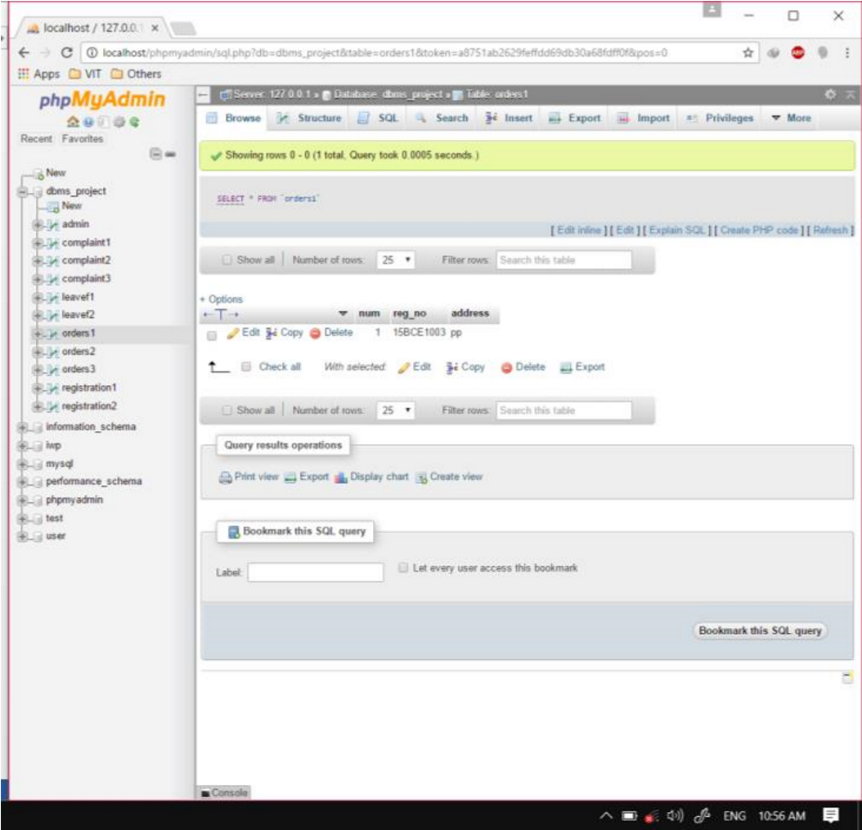

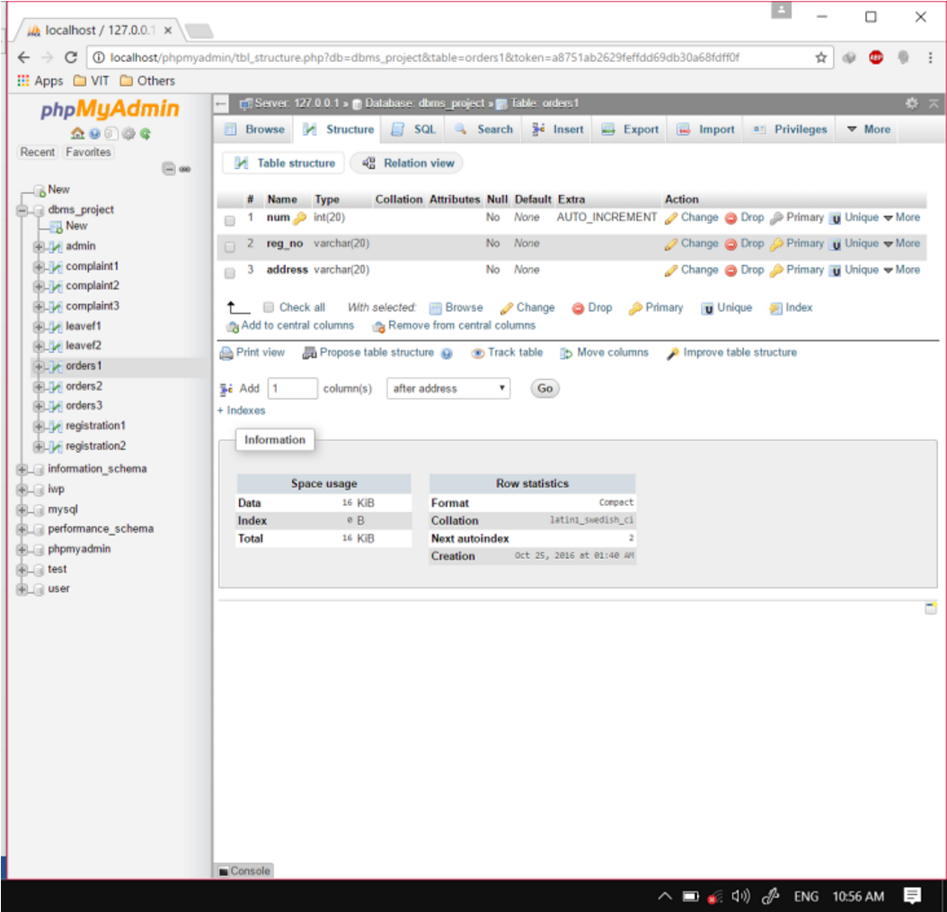

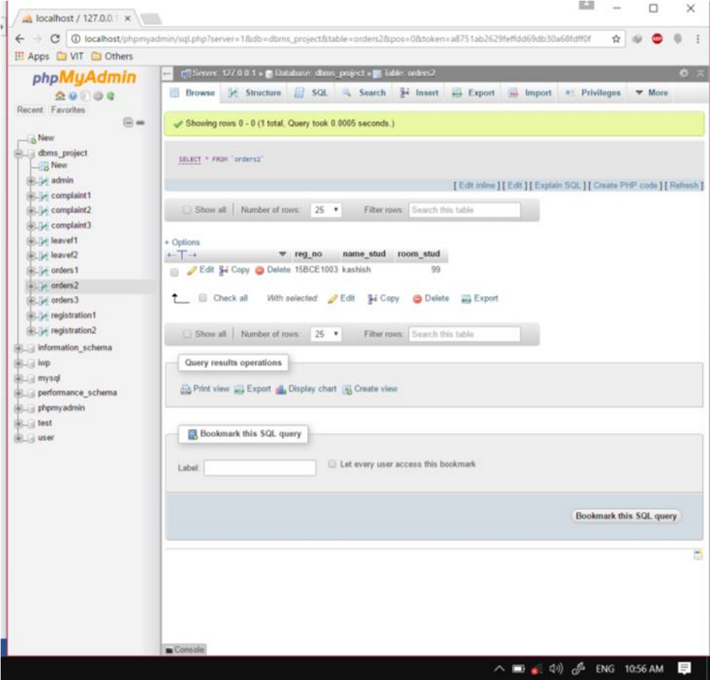

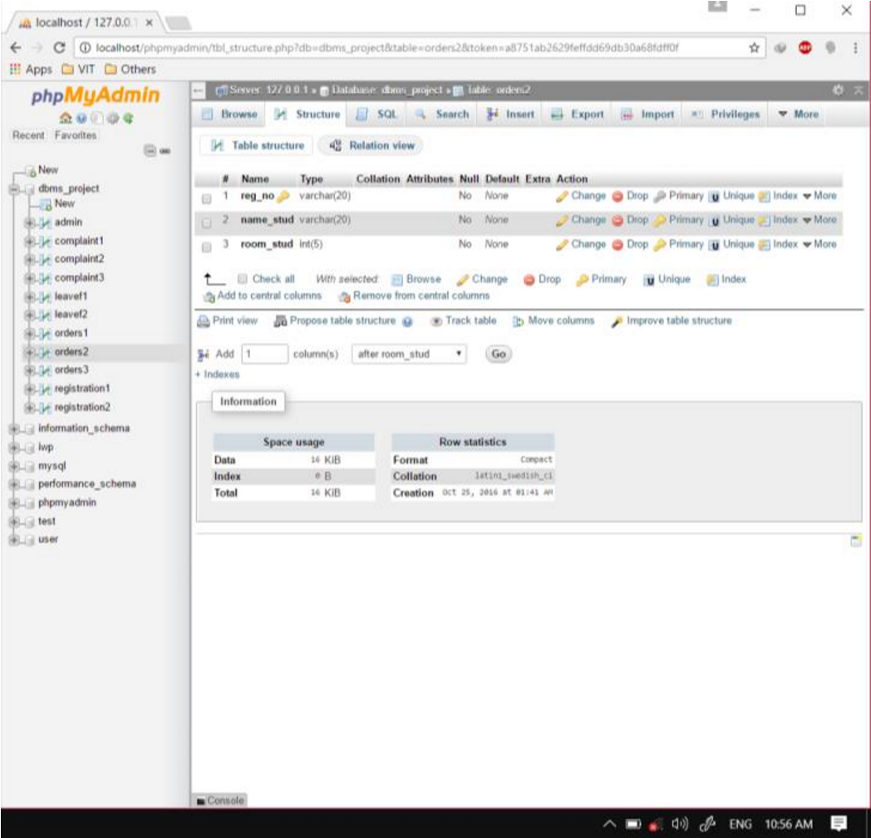

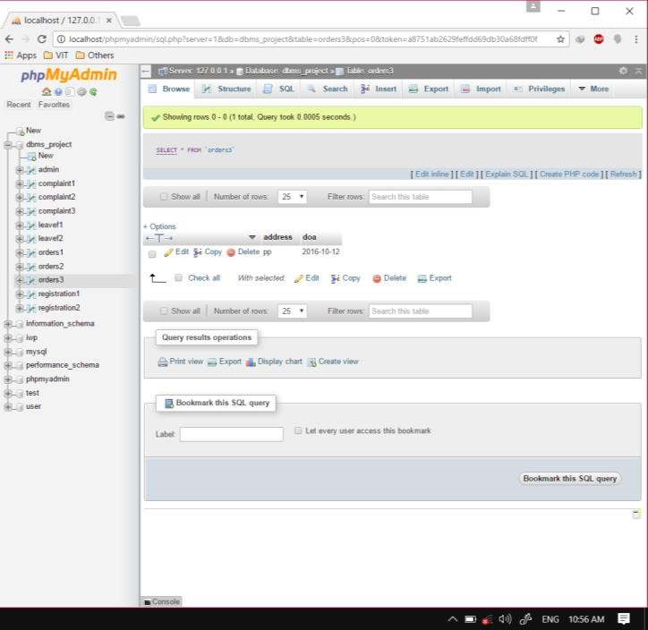

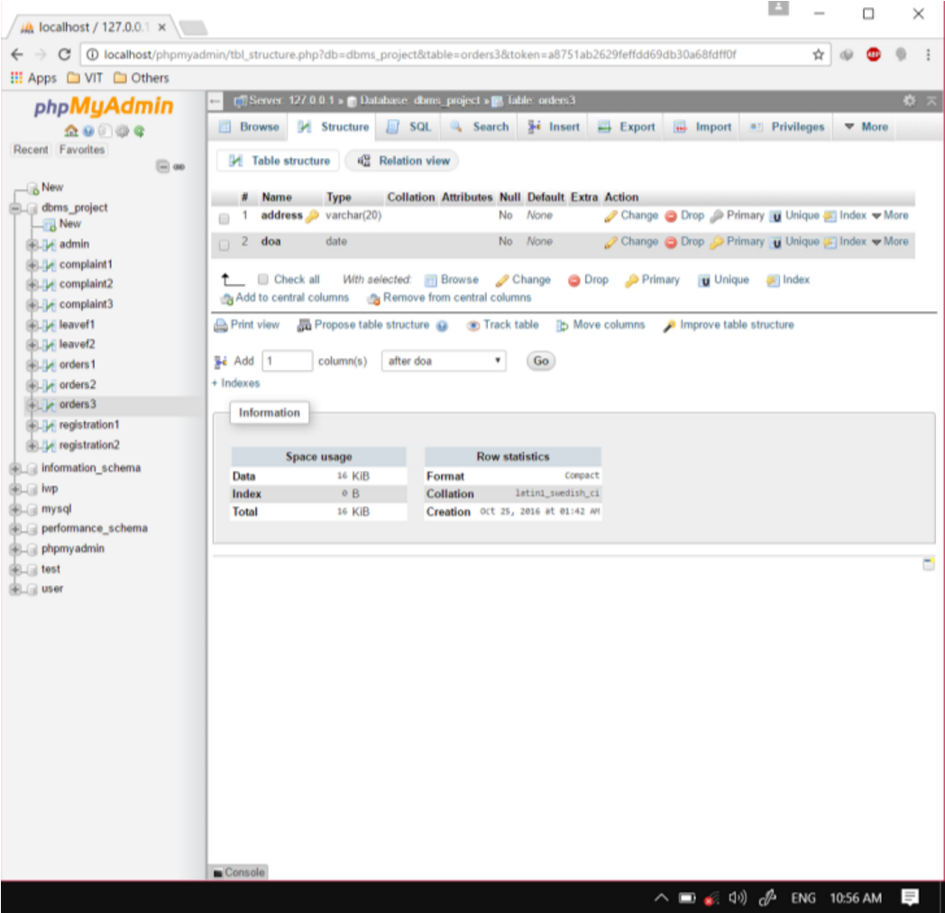

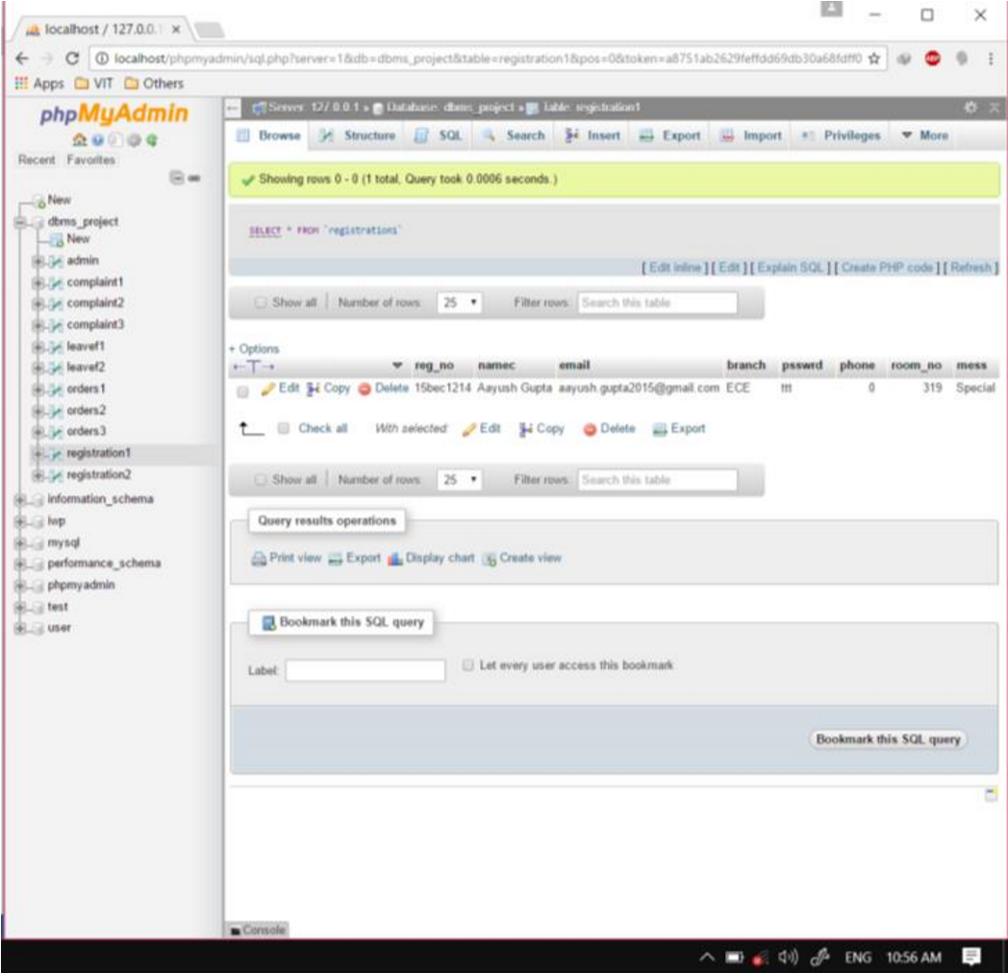

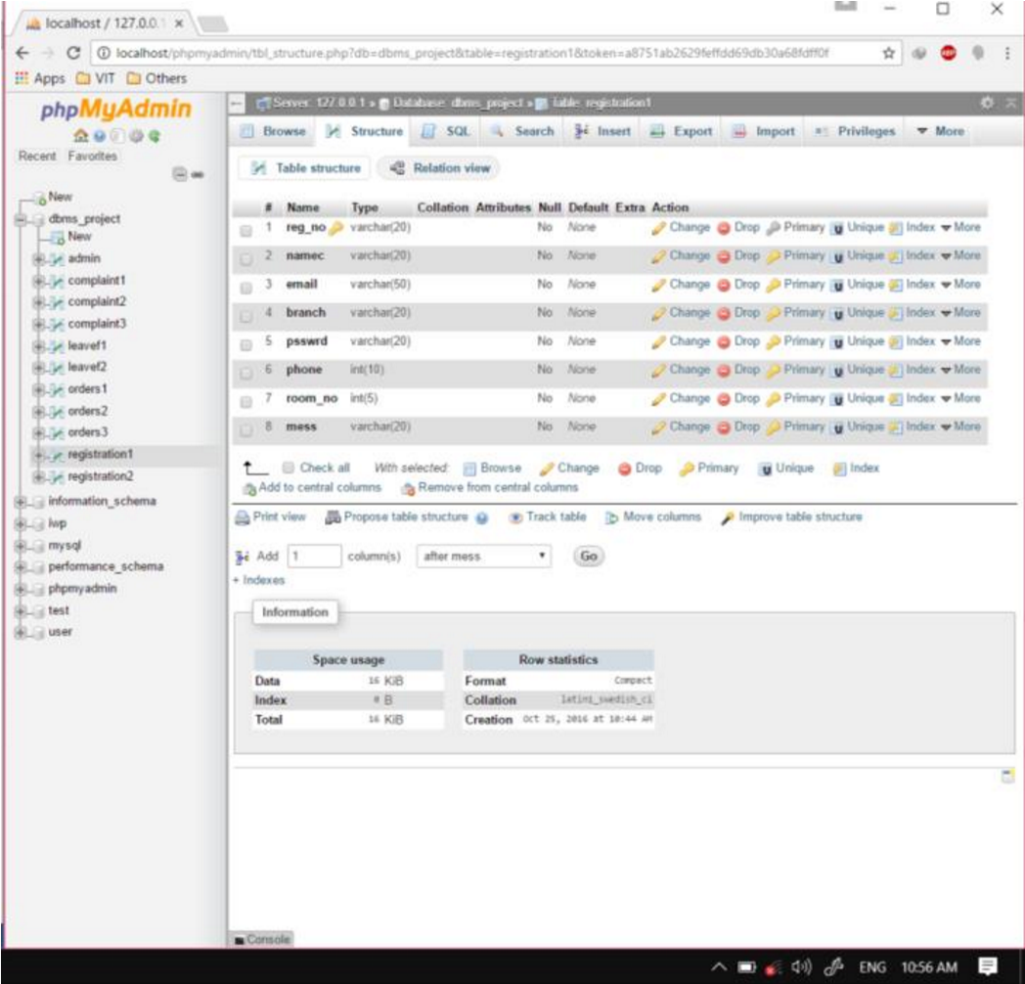

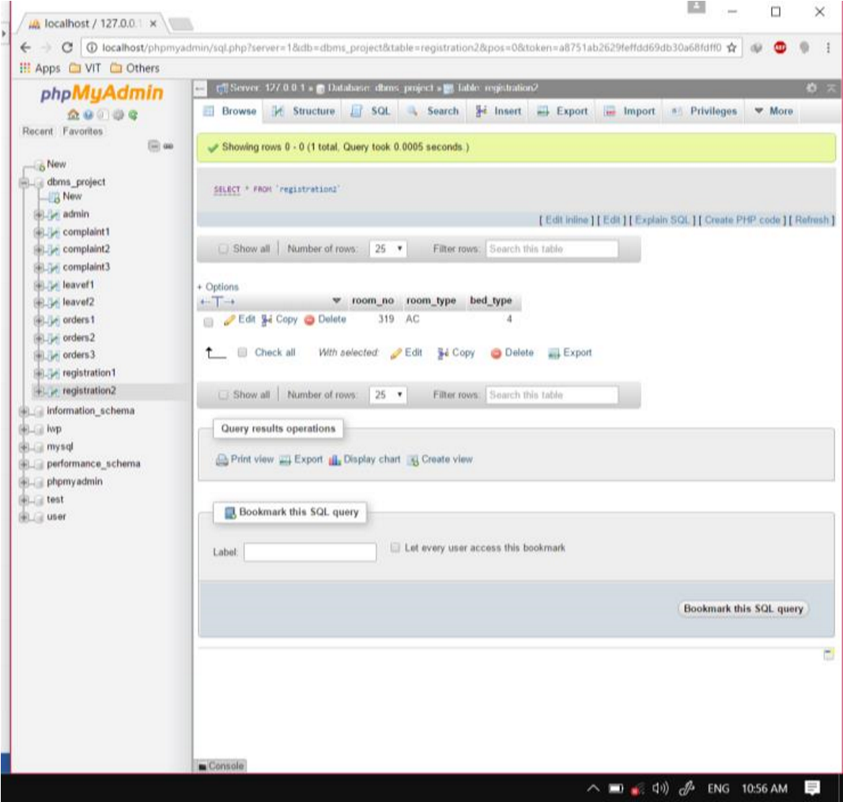

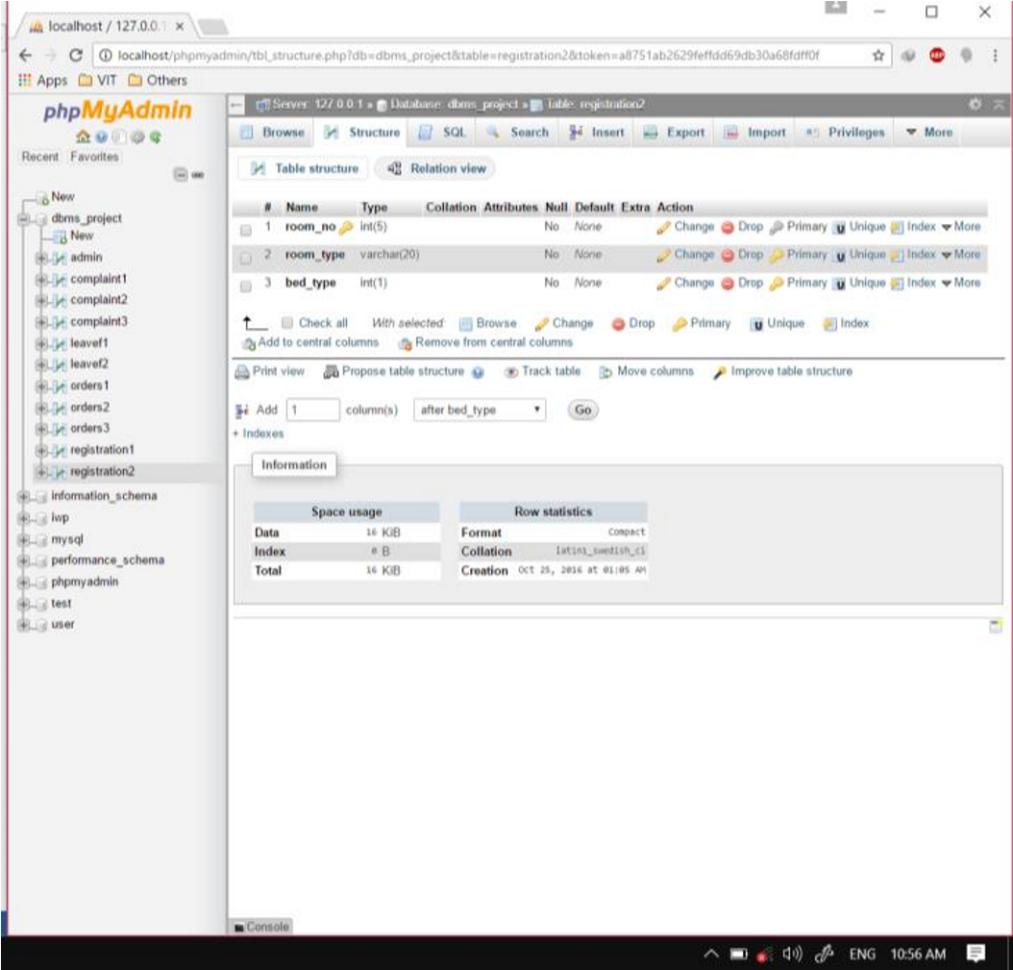

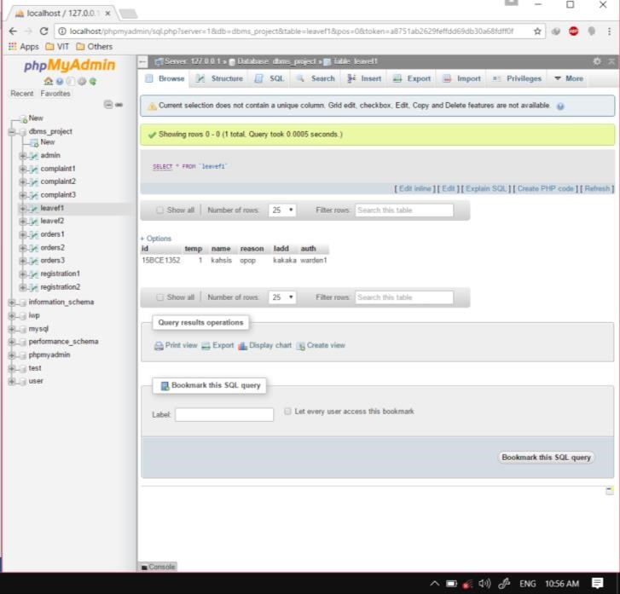

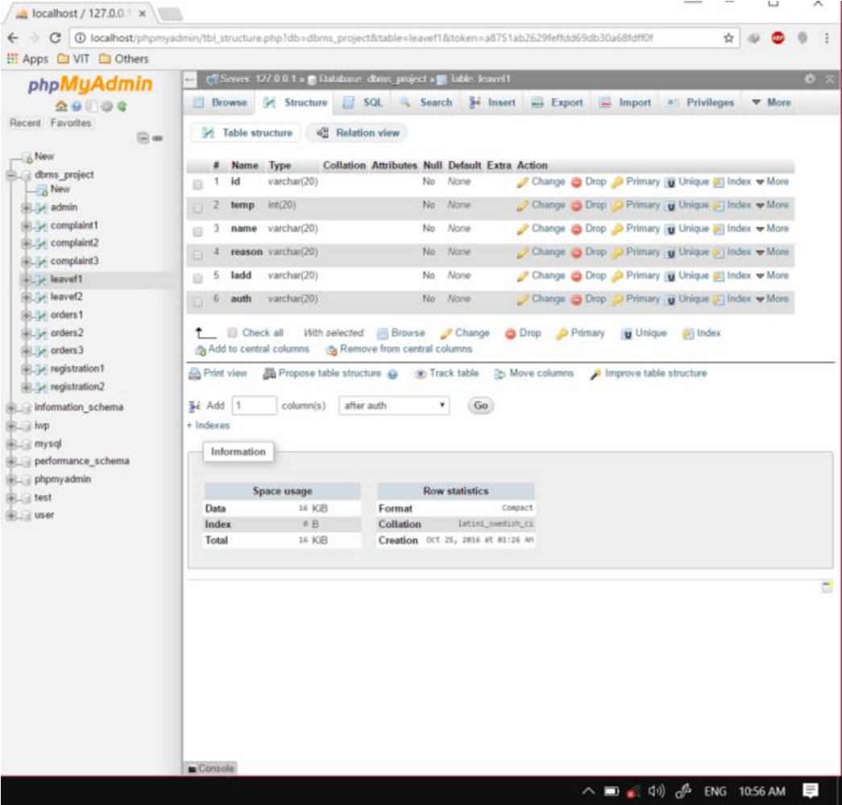

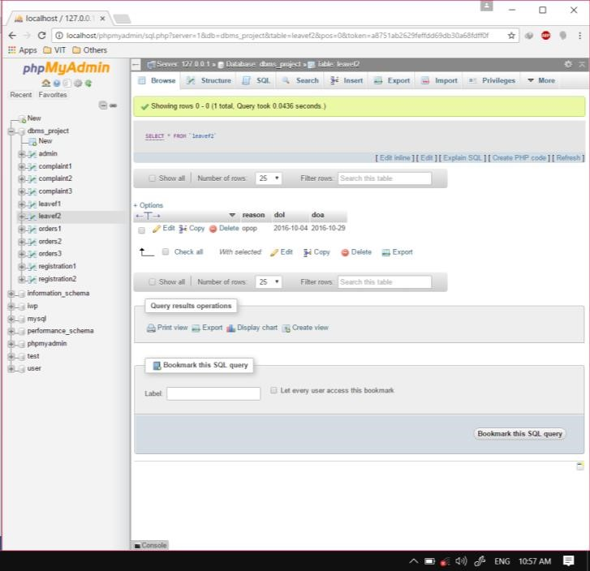

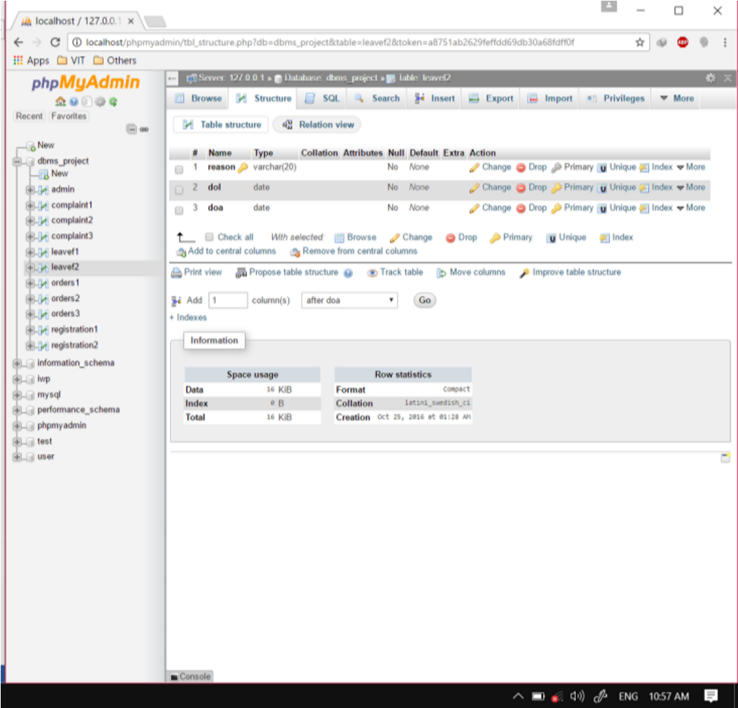

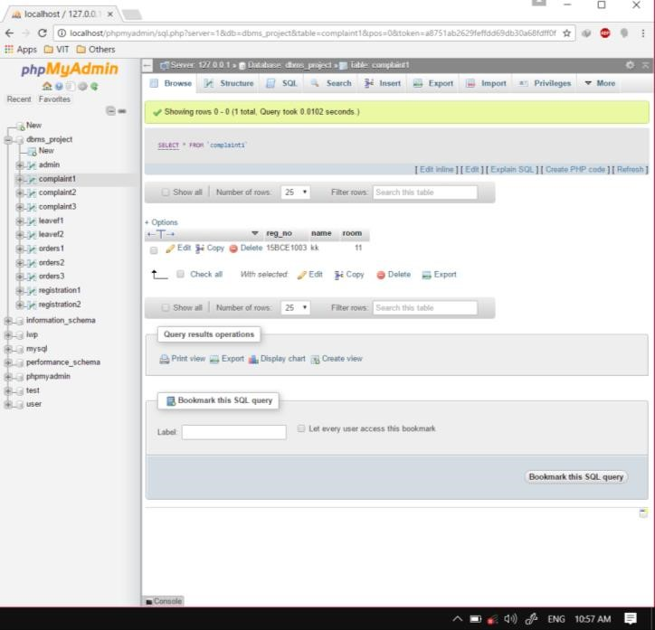

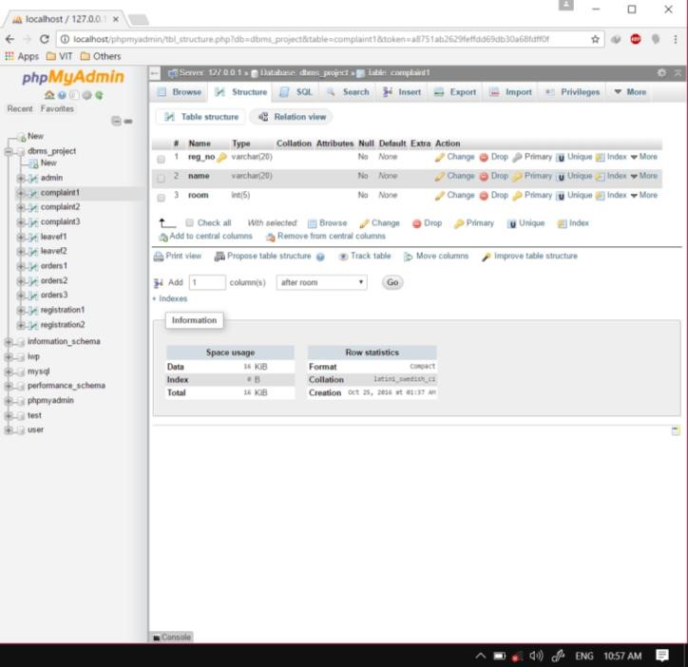

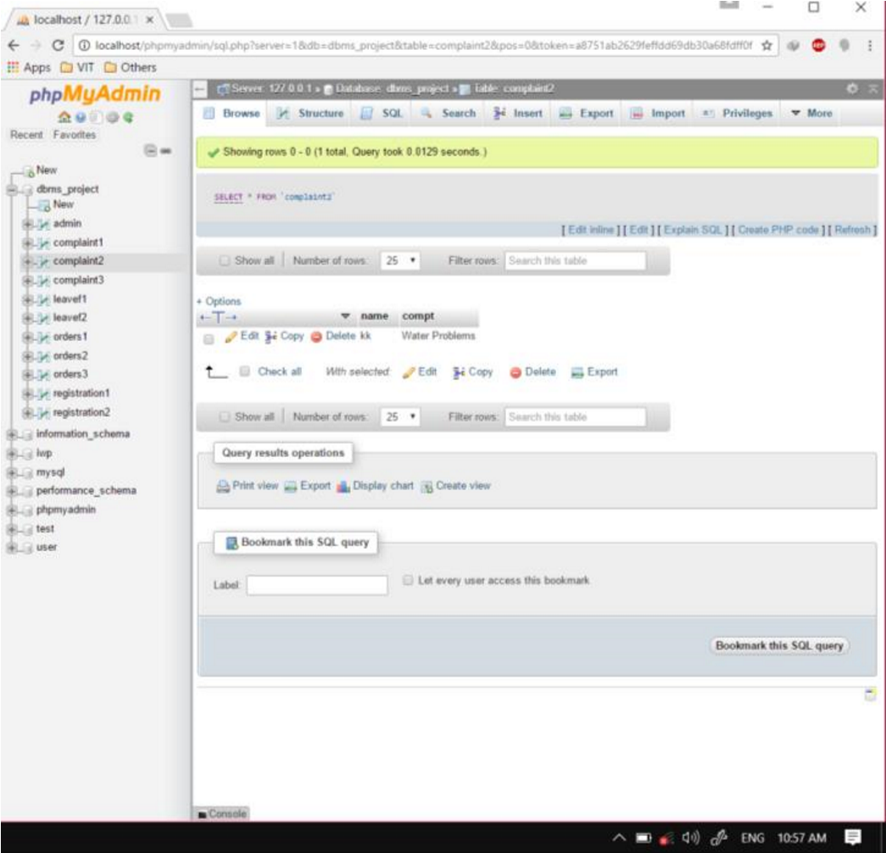

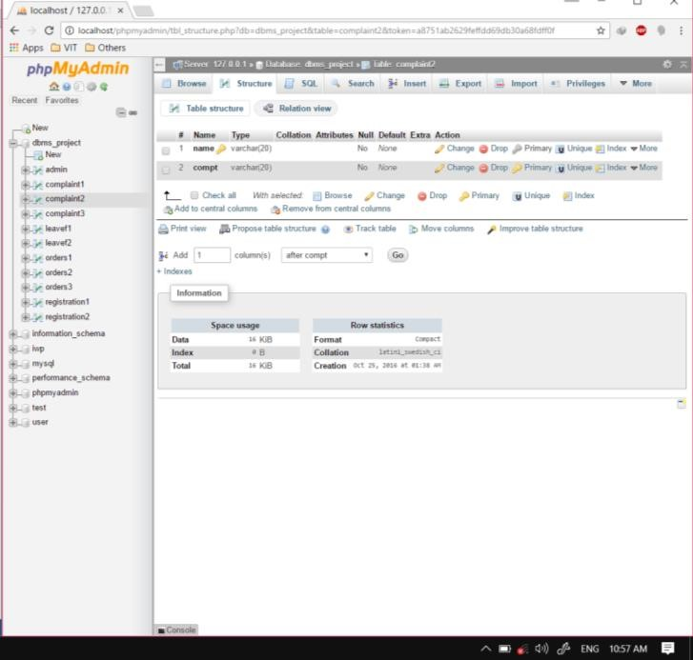

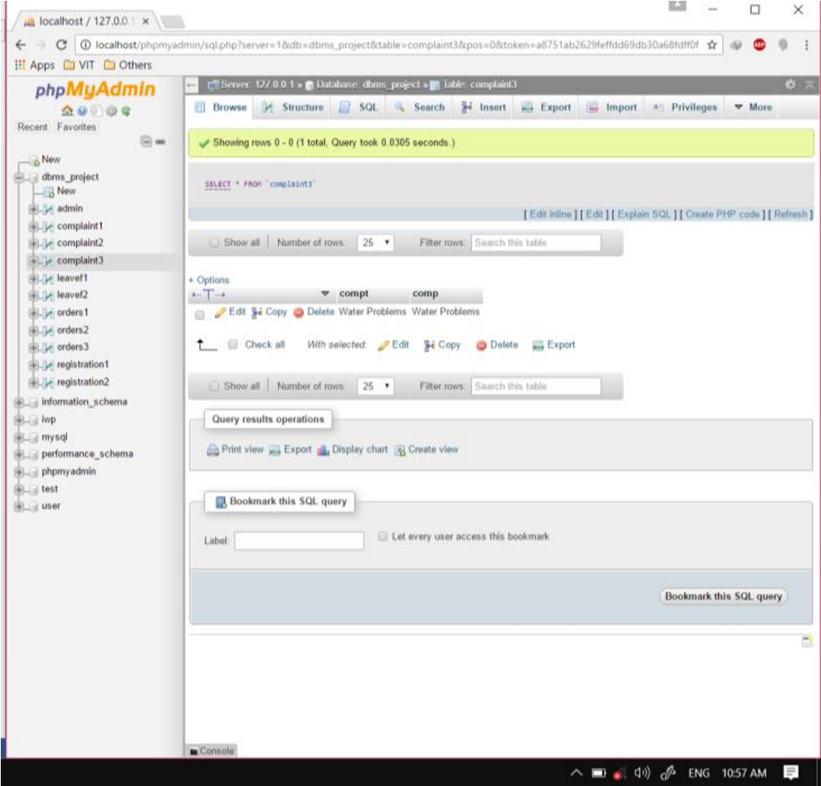

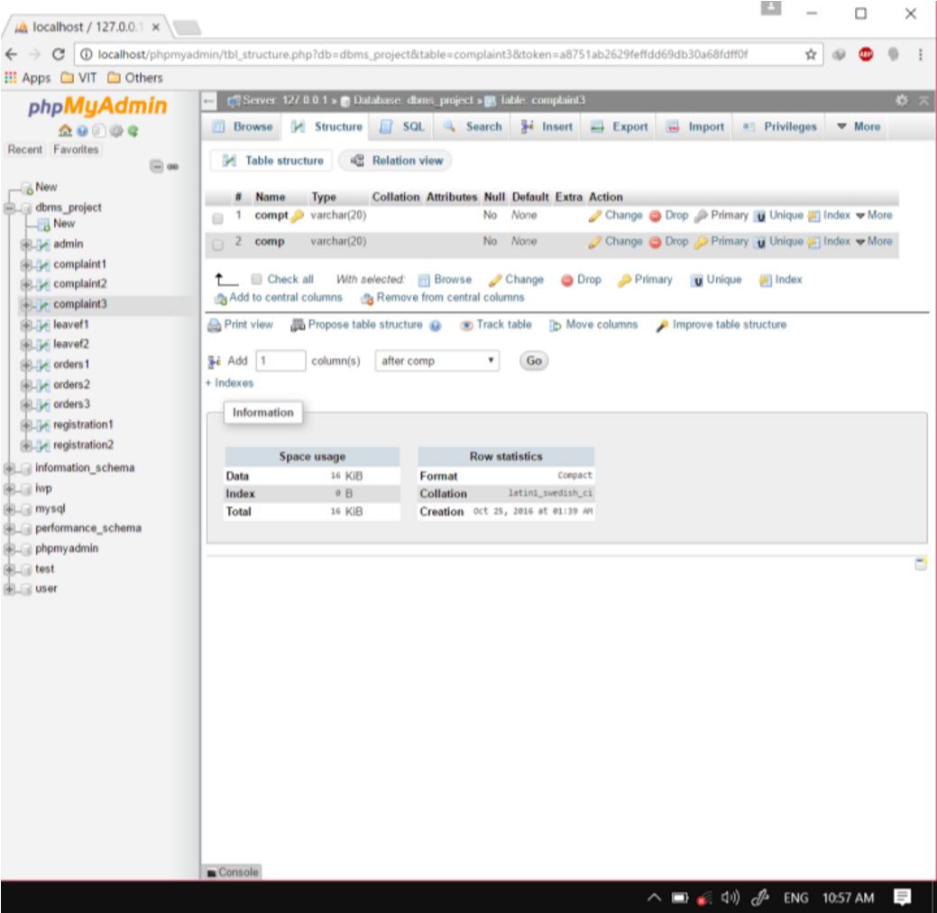

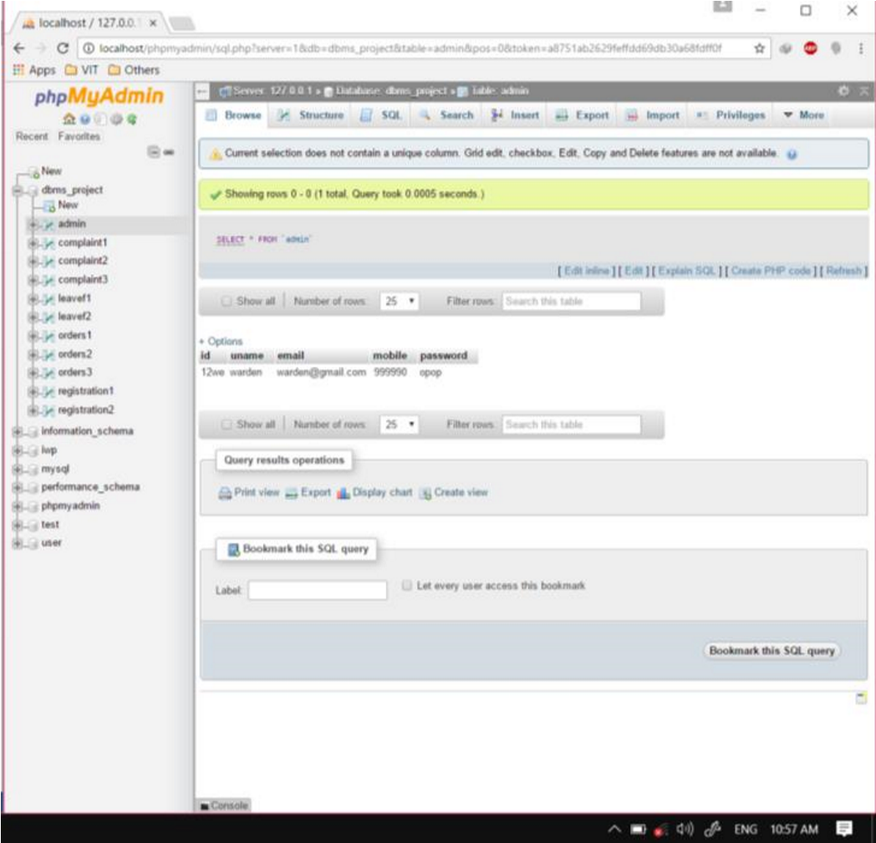

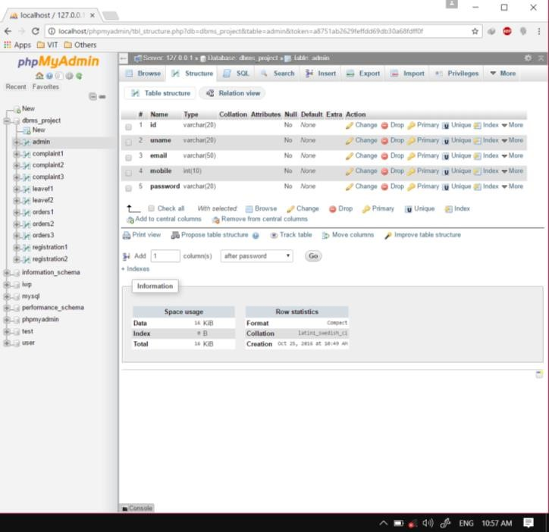

**Sample Code**

The main functionality of the website is to search student and get results based on the search query.

The code given is-:

<?php

if(isset($_POST['submit']))

{

$search=$_POST['search'];

if(is_numeric($search[0]) && is_numeric($search[1]) && !is_numeric($search[2]))

{

$query1="select * from registration where reg_no='".$search."'";

$r=@mysql_query($query1) or die("no"); while($row=@mysql_fetch_array($r)){ echo "<div class='container1' id='signup'>

<div class='header'>

<h3>Result</h3>

</div>

<div class='sep'></div>

<p>Registration number: $row[reg_no] &nbsp

&nbsp&nbsp&nbsp&nbsp&nbsp&nbsp&nbsp&nbsp&nbsp&nbsp&nbsp Name: $row[namec]</p>

<p>Email: $row[email] &nbsp

&nbsp&nbsp&nbsp&nbsp&nbsp&nbsp&nbsp&nbsp&nbsp&nbsp&nbsp Branch: $row[branch]</p>

<p>Room No: $row[room_no] &nbsp

&nbsp&nbsp&nbsp&nbsp&nbsp&nbsp&nbsp&nbsp&nbsp&nbsp&nbsp Room Type:

$row[room_type]</p>

<p>Bed type: $row[bed_type]&nbsp

&nbsp&nbsp&nbsp&nbsp&nbsp&nbsp&nbsp&nbsp&nbsp&nbsp&nbsp Mess: $row[mess]</p>

</div><br>";

}

}

else if(is_numeric($search) && (strlen($search)==3 || strlen($search)==4) )

{

$query2="select * from registration where room_no='".$search."'";

$r=@mysql_query($query2) or die("no"); while($row=@mysql_fetch_array($r)){ echo "<div class='container1' id='signup'>

<div class='header'>

<h3>Result</h3>

</div>

<div class='sep'></div>

<p>Registration number: $row[reg_no] &nbsp

&nbsp&nbsp&nbsp&nbsp&nbsp&nbsp&nbsp&nbsp&nbsp&nbsp&nbsp Name: $row[namec]</p>

<p>Email: $row[email] &nbsp

&nbsp&nbsp&nbsp&nbsp&nbsp&nbsp&nbsp&nbsp&nbsp&nbsp&nbsp Branch: $row[branch]</p> <p>Room No: $row[room_no] &nbsp

&nbsp&nbsp&nbsp&nbsp&nbsp&nbsp&nbsp&nbsp&nbsp&nbsp&nbsp Room Type:

$row[room_type]</p>

<p>Bed type: $row[bed_type]&nbsp

&nbsp&nbsp&nbsp&nbsp&nbsp&nbsp&nbsp&nbsp&nbsp&nbsp&nbsp Mess: $row[mess]</p>

</div><br>";

}

}

else

{

$query3="select * from registration where namec='".$search."'";

$r=@mysql_query($query3) or die("no"); while($row=@mysql_fetch_array($r)){ echo "<div class='container1' id='signup'>

<div class='header'>

<h3>Result</h3>

</div>

<div class='sep'></div>

<p>Registration number: $row[reg_no] &nbsp

&nbsp&nbsp&nbsp&nbsp&nbsp&nbsp&nbsp&nbsp&nbsp&nbsp&nbsp Name: $row[namec]</p>

<p>Email: $row[email] &nbsp

&nbsp&nbsp&nbsp&nbsp&nbsp&nbsp&nbsp&nbsp&nbsp&nbsp&nbsp Branch: $row[branch]</p>

<p>Room No: $row[room_no] &nbsp

&nbsp&nbsp&nbsp&nbsp&nbsp&nbsp&nbsp&nbsp&nbsp&nbsp&nbsp Room Type:

$row[room_type]</p>

<p>Bed type: $row[bed_type]&nbsp

&nbsp&nbsp&nbsp&nbsp&nbsp&nbsp&nbsp&nbsp&nbsp&nbsp&nbsp Mess: $row[mess]</p>

</div>";

}

}

echo "<br>";

}

?>



**BIBLIOGRAPHY**

[www.google.com](http://www.google.com/) [www.wikipedia.org.](http://www.wikipedia.org/) [www.w3schools.com](http://www.w3schools.com/)

DBMS book